**Chapter 1**

**INTRODUCTION**

* 1. **General**

The food court offers a variety of cuisines under an umbrella with a common eating space. It has become so common that even multinational companies and colleges changed their existing system of canteen to that of food courts. Though the idea behind a food court is brilliant, it is very time consuming. The problem starting from getting a card to avail the facilities, to stand in a queue to place our order and again, to wait for the food to be served. It can cost a lot of time and energy in the sides of both the customers and the employees. The proposed application can reduce this tension to a large extent. By registering in this web application, both by the restaurants and customers, one can order food through online in advance so that they won't have to wait for a long time. The vendors can notify customers when their food is ready, therefore saving a lot of time and reducing the crowd in front of the food stalls rather effectively.

* 1. **Objective**

The objective of this project is to develop a web based application for a food court to automate the functionalities of that food court. Using this application the customers can easily order food whatever they need and it is also useful for the vendors to manage their business. My main intention for this project is to reduce the complexity of food court functioning and also to save the time as well as the energy. The customers can view different vendors, food items, description, price, rating, top selling products etc using this application. It will help them to choose food items without standing in a queue. They can also pre order it before entering to the food court as well as make payment. Once the order gets ready to be served, the customer will be notified through the application so

that the customer need not to wait for the food. The vendors will notified for each new orders an they can decide whether the order should accepted or declined. Vendors can add new food items, update the food status such as availability, edit details through the vendor module. It makes very easy for the vendors to manage their business. So the proposed system will reduce most of the manual works and it will save the time.

**Chapter 2**

**SYSTEM STUDY AND ANALYSIS**

In this section the existing manual system is explained in details along with the proposed solution. A detailed study has been done over the existing system and by referring lots of web resources, the idea of using the proposed technology and language were selected based on the problems to be overcome and the features of the applications.

**2.1 Problem Definition**

Usually in almost all food courts the conventional model is used for their transactions. Though the idea behind a food court is brilliant, it is very time consuming. The problem starting from getting a card to avail the facilities, to stand in a queue to place our order and again, to wait for the food to be served. It can cost a lot of time and energy in the sides of both the customers and the employees. A lot of manual work has to be done for this existing system. And it is also a headache process for the vendors to manage their business.

**2.2 Existing System**

In Existing System we are using a **Prepaid POS Card** for availing the food court services. And the process will be as follows,

* Customers obtain a rechargeable card at the entrance.
* Customer has to recharge the card for ordering food.
* Customer hands over the card to place an order.
* The server swipes the card and serves the order.
* The sale amount is instantly deducted from the card balance.
* The customer can recharge the card as and when required.

**2.3 Proposed System**

The proposed system is a web based application for automating all the above mentioned processes in the existing system. Customers can see the different food items, vendors, and top selling items in the customer module. They can also register and login for ordering food and also they can make a wish list as well. They can pre-order the food even before enter into the food court so that they don’t need to wait for the food to be delivered. Once the food is ready they will get a notification regarding that. Vendors can also register with the vendor module.

They can add new food items, edit existing food’s details, view the orders etc through their own page. They can also change the status of existing food items whether it is available or not so that only the available items will be shown in the customer module.

The proposed application can reduce the tensions in the existing system to a large extent. By registering in this web application, both by the restaurants and customers, one can order food through online in advance so that they won't have to wait for a long time. So it saves a lot of time and reduces the crowd in front of the food stalls rather effectively.

**2.4 System Requirements**

The system requirements include the hardware and software requirements. This may serve as the basis for contract for the implementation of the system and should therefore be a complete and consistent specification of the whole system. To be used efficiently, all computer software needs certain hardware components that are often used as guidelines. Hence the proposed system needs to meet the following requirements before the client beings to work to avoid errors during the work time.

* + 1. **Hardware Requirements**

|  |  |
| --- | --- |
| **Processor :** | i5 or higher |
| **Ram :** | 4 GB |
| **Hard Disk :** | 500 GB |

Table No: 2.1 Hardware Requirements

* + 1. **Software Requirements**

|  |  |
| --- | --- |
| **Front End Tool :** | PHP |
| **Back End Tool :** | MySQL |
| **Server :** | XAMPP v7.2.7 |
| **Text Editor :** | Atom v1.28.2 |
| **Browser :** | Google Chrome |
| **Operating System :** | Windows 10 |

Table No: 2.2 Software Requirements

**Chapter 3**

**SYSTEM DESIGN**

**3.1 ARCHITECTURAL DESIGN**

Architectural design is the high level structure. It is an early stage of the system design process. It represents the link between specification and design processes and carried out in parallel with some specification activities.

**3.1.1 ER DIAGRAM**

Entity Relationship model is a data model for describing the data or information aspects of a business domain or its process requirements, in an abstract way that lends itself to ultimately being implemented in a database such as a relational database.FF

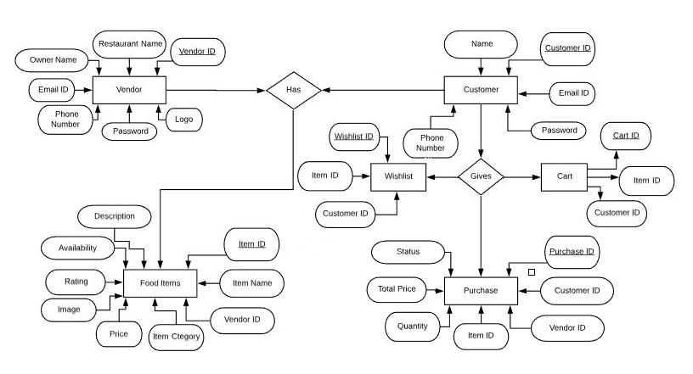

Figure No: 3.1 ER Diagram

**3.1.2 DATA FLOW DIAGRAM**

Data Flow Diagram is a graphical representation of the “flow” of data through an information system, modelling its process aspects. A DFD is often used as a preliminary step to create an overview of the system which can later be elaborated.

Function

Input / Output

Flow

Stored Data

Figure No: 3.2 Data Flow Diagram

A DFD shows what kinds of data will be input to and output from the system, where the data will come from and go to, and where the data will be stored. It does not show information about the timing of processes, or information about whether processes will operate in sequence or in parallel.

**DFD LEVEL 0 :**

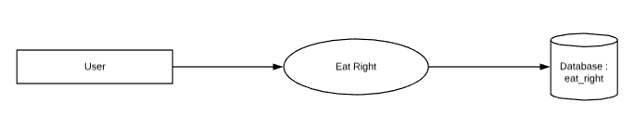

Figure No: 3.3 DFD Level 0

**DFD LEVEL 1 :**

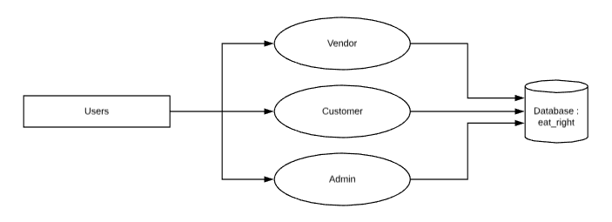

Figure No: 3.4 DFD Level 1

**DFD LEVEL 2.1 : Customer Module**

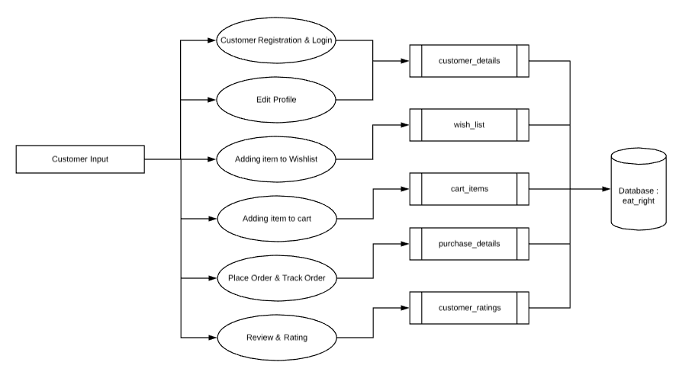

Figure No: 3.5 DFD Level 2.1

**DFD LEVEL 2.2 : Vendor Module**

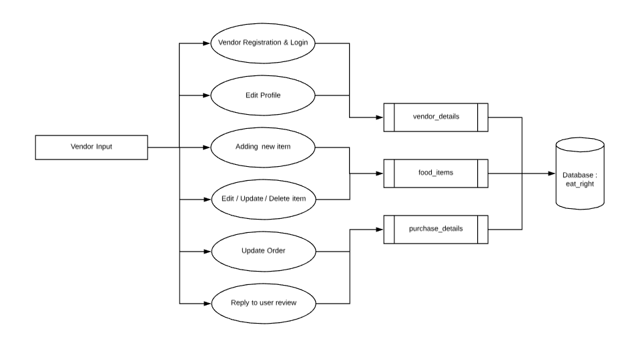

Figure No: 3.6 DFD Level 2.2

**DFD LEVEL 2.3 : Admin Module**

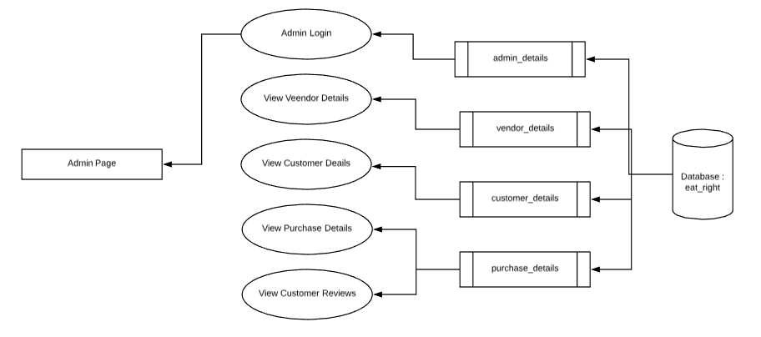

Figure No: 3.7 DFD Level 2.3

**3.2 DATABASE DESIGN**

|  |  |  |
| --- | --- | --- |
| **Table Name : admin_details** | | |
|
| **FIELD NAME** | **DATA TYPE** | **CONSTRAINTS** |
| admin_id | int(3) | Not Null |
| admin_email_id | varchar(50) | Not Null |
| admin_name | varchar(30) | Not Null |
| admin_password | varchar(30) | Not Null |

Table No: 3.1 admin_details

|  |  |  |
| --- | --- | --- |
| **Table Name : vendor_details** | | |
|
| **FIELD NAME** | **DATA TYPE** | **CONSTRAINTS** |
| vendor_id | int(3) | Not Null |
| vendor_name | varchar(30) | Not Null |
| restaurant_name | varchar(50) | Not Null |
| vendor_mail | varchar(30) | Not Null |
| vendor_contact | bigint(10) | Not Null |
| vendor_password | varchar(30) | Not Null |
| restaurent_logo | varchar(30) | Not Null |

Table No: 3.2 vendor_details

|  |  |  |
| --- | --- | --- |
| **Table Name : customer_details** | | |
|
| **FIELD NAME** | **DATA TYPE** | **CONSTRAINTS** |
| customer_id | int(4) | Not Null |
| customer_name | varchar(30) | Not Null |
| customer_mail | varchar(50) | Not Null |
| customer_ph_no | bigint(10) | Not Null |
| customer_password | varchar(30) | Not Null |

Table No: 3.3 customer_details

|  |  |  |
| --- | --- | --- |
| **Table Name : food_items** | | |
|
| **FIELD NAME** | **DATA TYPE** | **CONSTRAINTS** |
| item_id | int(5) | Not Null |
| vendor_id | int(3) | Not Null |
| item_name | varchar(30) | Not Null |
| item_category | varchar(30) | Not Null |
| item_price | Float | Not Null |
| item_rating | int(1) | Not Null |
| item_availability | varchar(1) | Not Null |
| item_image | varchar(30) | Not Null |
| item_description | Longtext | Not Null |
| total_orders | int(10) | Not Null |

Table No: 3.4 admin_details

|  |  |  |
| --- | --- | --- |
| **Table Name : purchase_details** | | |
|
| **FIELD NAME** | **DATA TYPE** | **CONSTRAINTS** |
| purchase_id | int(10) | Not Null |
| customer_id | int(4) | Not Null |
| vendor_id | int(3) | Not Null |
| item_id | int(5) | Not Null |
| item_quantity | int(3) | Not Null |
| total_price | Float | Not Null |
| purchase_date_time | Datetime | Not Null |
| purchase_status | varchar(30) | Not Null |
| user_comments | Longtext | Not Null |
| vendor_comments | Longtext | Not Null |
| user_rating | int(1) | Not Null |

Table No: 3.5 purchase_details

|  |  |  |
| --- | --- | --- |
| **Table Name : purchase_head** | | |
|
| **FIELD NAME** | **DATA TYPE** | **CONSTRAINTS** |
| order_id | int(10) | Not Null |
| customer_id | int(4) | Not Null |
| total_amount | Float | Not Null |
| Time | Datetime | Not Null |
| Status | varchar(30) | Not Null |

Table No: 3.6 purchase_head

|  |  |  |
| --- | --- | --- |
| **Table Name : cart_items** | | |
|
| **FIELD NAME** | **DATA TYPE** | **CONSTRAINTS** |
| cart_id | int(10) | Not Null |
| customer_id | int(10) | Not Null |
| food_id | int(10) | Not Null |

Table No: 3.7 cart_items

|  |  |  |
| --- | --- | --- |
| **Table Name : wish_list** | | |
|
| **FIELD NAME** | **DATA TYPE** | **CONSTRAINTS** |
| cart_id | int(10) | Not Null |
| customer_id | int(10) | Not Null |
| food_id | int(10) | Not Null |

Table No: 3.8 wish_list

**3.3 GRAPHICAL USER INTERFACE DESIGN**

GUI design is a type of interface that allows users to interact with electronic devices through graphical icons and visual indicators such as secondary notation as opposed to text based interface, typed command labels or text navigation.

**Vendor Registration Page**

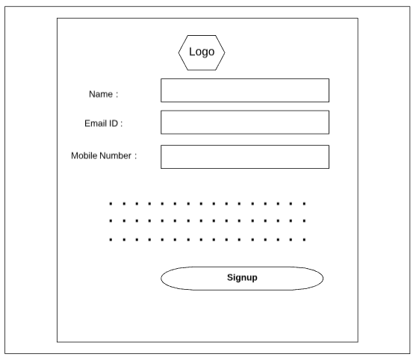

Figure No: 3.8 Vendor Registration

**Vendor Login Page**

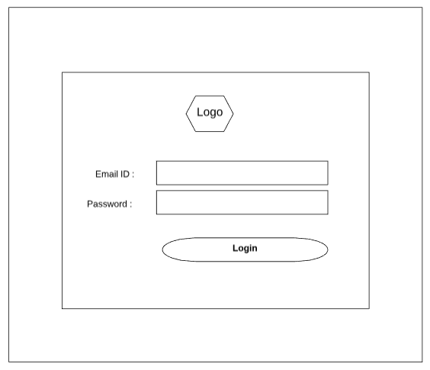

Figure No: 3.9 Vendor Login

**Vendor Home Page**

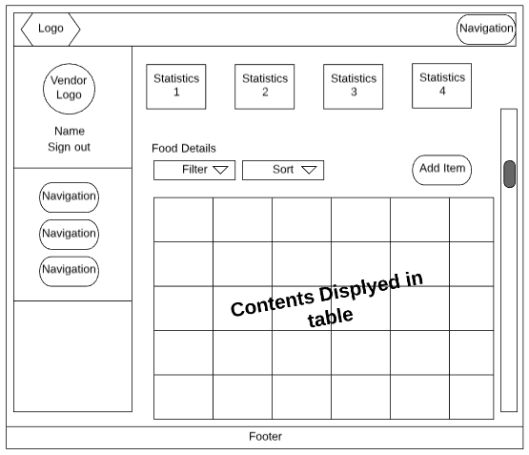

Figure No: 3.10 Vendor Home Page

**Customer Registration Page**



Figure No: 3.11 Customer Registration

**Customer Login Page**



Figure No: 3.12 Customer Login Page

**Customer Home Page**

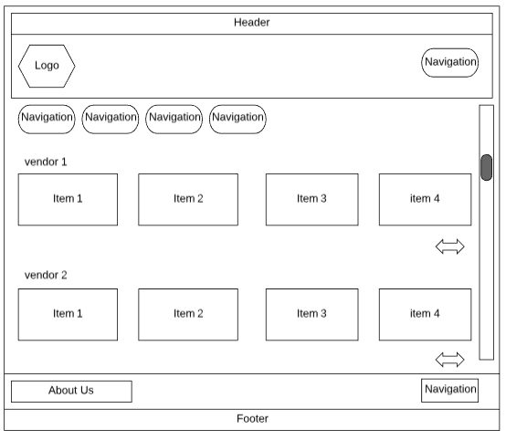

Figure No: 3.13 Customer Home Page

**Admin Login Page**



Figure No: 3.14 Admin Login Page

**Admin Home Page**

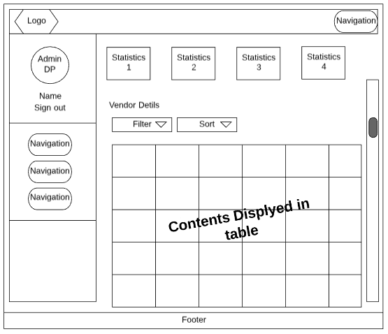

Figure No: 3.15 Admin Home Page

**Chapter 4**

**PROJECT DESCRIPTION**

The system after careful analysis has been identified that there are three main modules and each modules comprises of several sub modules. The main modules are as follows,

* **Admin**
* **Vendor**
* **Customer**

1. **Admin** 
   1. **Approve/Disapprove:** Admin can approve/disapprove the registration of vendors.
   2. **Remove Vendors:** Admin can remove a vendor if the vendor is no longer a part of the food court.
   3. **View Details:** Admin can view Vendor, Customer & Purchase Details.
   4. **Feedback:** Admin can also see the feedback given by the customers.
2. **Vendors**
   1. **Register:** The Vendors need to register first.
   2. **Login:** The vendors need to login using valid login credentials in order to access the application.
   3. **Add Items:** Vendor can add new food items with details such as name, image, cost, description, etc.
   4. **Edit Items:** Vendors can also edit the details of the food items already added.
   5. **View / Update / Delete Items:** Vendor can also manage the items easily.
   6. **View / Update Orders:** Can view all the food orders received from the customer and also can update the status of order received.
   7. **Approximate time to deliver:** Vendors can set the approximate time they will take to deliver the order.
   8. **View Previous Orders & Customer Feedback:** Vendors can also view previous order history and Customer review. And also they can reply to the customer.
3. **Customer**
   1. **Register:** Customers can register to the application with basic details and they can create a valid login id and password.
   2. **Login:** Customers can login to the application using their valid login credentials in order to do transactions in the application.
   3. **View Items:** All the food items will be displayed to the customer at once with description, cost and other informations.
   4. **Add to Wishlist:** Single or multiple food items can be added to wishlist so that they can easily order them whenever they need.
   5. **Add to Cart:** Single or multiple food items can be added to cart and can also specify the needed quantity.
   6. **Order and Pay:** Order can be placed of selected food items and can also pay the bill using payment gateways.
   7. **Approximate time to deliver:** Customer can see the approximate time to deliver and, once the order is ready to serve the application will give an alert to the customer.
   8. **Track Order:** Customer can track the status of their orders.
   9. **Order History:** All the past and recent order will be displayed.

**Chapter 5**

**SYSTEM DEVELOPMENT**

**5.1 TOOLS AND TECHNOLOGIES USED**

**PHP (Hypertext Preprocessor)**

PHP supports variable usage without declaring its data type. It will be taken at the time of the execution based on the type of data it has on its value. PHP is a widely used open source general purpose for scripting purpose (i.e.) is suited for web development and can be embedded into html. It is platform independent. It can be run on every environment. PHP can easily perform communication between front- end and back-end. We can easily retrieve the data from the database invoking the queries in PHP.

**BOOTSTRAP**

Anybody with the basic knowledge of HTML and CSS can start using bootstrap. It is a front- end designing language. It contains HTML- and CSS based design templates for typography, forms, buttons, navigation and other interface components, as well as optional JavaScript extensions. It is the combination of lots of CSS properties. It is used for responsive design. Bootstrap’s responsive CSS adjust to phone, tablets, and desktops. Bootstrap is compatible to all modern browsers (E.g. Opera Chrome, Safari, etc.). In bootstrap mobile-first styles are part of core framework. Bootstrap is responsive, mobile- first, prevailing, and front- end framework, which is developed along with CSS, JavaScript, and HTML. Bootstrap has many benefits from scratch for every web development project and one such reason is the huge number of resources accessible for Bootstrap. In addition to the regular HTML elements, Bootstrap contains other commonly used interface elements. The components are implemented as CSS classes, which must be applied to certain HTML elements in a page. These style sheets are generally compiled into a bundle and included in web pages, but individual components can be included or removed. Bootstrap provides a number of configuration variables that control things such as colour and padding of various components.

**MySQL**

The MySQL development project has made its source code available under the terms of the GNU General Public License, as well as under a variety of propriety agreements. MySQL is a central component of the LAMP open- source web application software stack Relational Database System: Like almost all other database systems on the market, MySQL is a relational database system. Client/Server Architecture: MySQL is a client/server system. There is a database server (MySQL) and arbitrarily many clients (application programmes), which communicate with the server, that is, they query data, save changes, etc. the clients can run on the same computer as the server or on another computer (communication via a local network or the internet). QL compatibility: MySQL supports as its database language- as its name suggests- SQL (Structured Query Language). SQL is a standardized language for querying and updating data and for the administration of a database. There are several SQL dialects. MySQL adheres to the current SQL standard, although with significant restrictions and a large number of extensions.

**XAMPP SERVER**

XAMPP is a free and open-source cross-platform web server solution stack package developed by Apache Friends, consisting mainly of the Apache HTTP Server, MariaDB database, and interpreters for scripts written in the PHP and Perl programming languages. Since most actual web server deployments use the same components as XAMPP, it makes transitioning from a local test server to a live server possible. It is often used for web development and internal testing, but may also be used to serve live websites. It allows you to create web applications with Apache, PHP and the MySQL database. It also comes with PHPMyAdmin to easily manage your database.

**5.2 PSEUDO CODE**

**Customer Module**

Customer module consists of several pages such as login page, registration page, home page, cart page, wishlist page, checkout page, order history, etc. Customer can register themselves and login using their User ID and Password that they have provided in the registration form. After login, customer can surf with the application by clicking the navigator links which are available on the top left of the webpage. Customers can do following transactions :

* To View / Edit personal information and password
* To view different food items that are available
* To view vendor specific food items that are available
* To view top selling food items that are available
* To Add / View / Delete items in their wishlist
* To Add / View / Delete items in their cart
* To place order with the items added in the cart
* To view the order status
* To view the order history
* To give review for a particular food item

**Vendor Module**

Vendor module consists of several pages such as login page, registration page, home page, food details page, add item page, edit item page, order page, etc. Vendor can register themselves and login using their User ID and Password that they have provided in the registration form. After login, vendor can surf with the application by clicking the navigator links which are available in the dashboard. Vendors can do following transactions

* To View / Edit personal information and password
* To View / Edit / Delete different food items that are added
* To view the order details
* To view the order history
* To view new orders
* To notify the customer about order status
* To give reply the review send by the customer

**Admin Module**

Admin module consists of several pages such as login page, home page, vendor details page, new vendor registration page, food details page, customer details page etc. Admin can login using their User ID and Password. After login, Admin can surf with the application by clicking the navigator links which are available in the dashboard. Admin can do following transactions

* To View different vendors details
* To update vendor status
* To view the customer details
* To view the food details

**5.3 SOURCE CODE**

<?php include("config.php");

if(isset($_POST['cart']))

{

$postData=$_POST;

if(!isset($_SESSION['user']))

{

echo "<script> alert('Please Login to your Account First.');</script>";

}

else

{

$insSQL=mysqli_query($con,"INSERT INTO cart_items VALUES ('','{$_SESSION['user']['id']}','{$postData['item_id']}','1');");

echo "<script> alert('1 item added to cart');window.location='index.php';</script>";

}

}

if(isset($_POST['delete']))

{

$postData=$_POST;

$insSQL=mysqli_query($con,"DELETE FROM cart_items WHERE cart_id='{$postData['cart_id']}'");

echo "<script> alert('1 item deleted from the cart');window.location='index.php';</script>";

}

if(isset($_POST['wish_add']))

{

$postData=$_POST;

if(!isset($_SESSION['user']))

{

echo "<script> alert('Please Login to your Account First.');window.location='index.php';</script>";

}

else

{

$insSQL=mysqli_query($con,"INSERT INTO wish_list VALUES ('','{$_SESSION['user']['id']}','{$postData['item_id']}');");

echo "<script> alert('1 item added to your Wishlist');window.location='index.php';</script>";

}

}

if(isset($_POST['wish_remove']))

{

$postData=$_POST;

$insSQL=mysqli_query($con,"DELETE FROM `wish_list` WHERE customer_id='{$_SESSION['user']['id']}' and food_id='{$postData['item_id']}'");

echo "<script> alert('1 item removed from your Wishlist');window.location='index.php';</script>";

}

?>

<!DOCTYPE html>

<html lang="en">

<head>

<meta charset="utf-8">

<meta http-equiv="X-UA-Compatible" content="IE=edge">

<meta name="viewport" content="width=device-width, initial-scale=1">

<title>Eat Right</title>

<!-- Google font -->

<link href="https://fonts.googleapis.com/css?family=Montserrat:400,500,700" rel="stylesheet">

</head>

<body>

<!-- HEADER -->

<header>

<!-- TOP HEADER -->

<div id="top-header">

<div class="container">

<ul class="header-links pull-left">

<li><a><i class="fa fa-phone"></i> +91- 9998885566</a></li>

<li><a><i class="fa fa-envelope-o"></i> eat.right@egmail.com</a></li>

<li><a><i class="fa fa-map-marker"></i> Loyola College, Chennai - 34</a></li>

</ul>

<ul class="header-links pull-right">

<?php if(!isset($_SESSION['user'])){ ?>

<li><a href="customer/login.php"><i class="fa fa-user-o"></i> My Account</a></li>

<?php }

else {

?>

<div class="dropdown">

<li><a onclick="myFunction()" class="dropbtn"><i class="fa fa-user-o"></i><?php echo $_SESSION['user']['name'];?></a></li>

<!--<li><a onclick="myFunction()" class="dropbtn"><i class="fa fa-user-o">Dropdown</a></li> -->

<div id="myDropdown" class="dropdown-content">

<a href="customer/edit_profile.php">Edit Account Details</a>

<a href="customer/change_password.php">Change Password</a>

<a href="customer/logout.php">Sign Out</a>

</div>

</div>

<script>

/* When the user clicks on the button,

toggle between hiding and showing the dropdown content */

function myFunction() {

document.getElementById("myDropdown").classList.toggle("show");

}

// Close the dropdown if the user clicks outside of it

window.onclick = function(event) {

if (!event.target.matches('.dropbtn')) {

var dropdowns = document.getElementsByClassName("dropdown-content");

var i;

for (i = 0; i < dropdowns.length; i++) {

var openDropdown = dropdowns[i];

if (openDropdown.classList.contains('show')) {

openDropdown.classList.remove('show');

}}}}

</script>

<?php

}

?>

</ul>

</div>

</div>

<!-- /TOP HEADER -->

<!-- MAIN HEADER -->

<div id="header">

<!-- container -->

<div class="container">

<!-- row -->

<div class="row">

<!-- LOGO -->

<div class="col-md-3">

<div class="header-logo">

<h1 style="color:red;">E<span style="color:white;">at </span>R<span style="color:white;">ight</span></h1>

</div>

</div>

<!-- Cart -->

<div class="dropdown">

<a class="dropdown-toggle" data-toggle="dropdown" aria-expanded="true">

<i class="fa fa-shopping-cart"></i>

<span>Your Cart</span>

<div class="qty">

<?php

$cartSQL=mysqli_query($con,"select count(*) as total_cart from cart_items where customer_id = '{$_SESSION['user']['id']}'");

$cartNum=mysqli_fetch_assoc($cartSQL);

echo $cartNum['total_cart'];

?>

</div>

</a>

<div class="cart-dropdown">

<form method="post">

<div class="cart-list">

<?php

$total=0;

$qty=1;

$cartQuery=mysqli_query($con,"SELECT c.cart_id, f.item_image, f.item_name, f.item_price FROM cart_items c JOIN food_items f ON c.customer_id = '{$_SESSION['user']['id']}' AND c.food_id=f.item_id");

while ($cartData=mysqli_fetch_assoc($cartQuery)){

?>

<div class="product-widget">

<div class="product-img">

<img src='asset/images/food_items/<?php echo $cartData['item_image']?>' alt="loading image">

</div>

<div class="product-body">

<form method="post">

<h3 class="product-name"><a href="#"><?php echo $cartData['item_name']?></a></h3>

<input type="hidden" name="cart_id" value="<?php echo $cartData['cart_id']; ?>">

<h4 class="product-price"><span class="qty">1x</span>Rs.<?php echo $cartData['item_price']?>.00</h4>

<h6 class="product-price"><button name=q-><</button> Qty <button name=q+>></button></h6>

<?php $total=$total+$cartData['item_price']; ?>

</div>

<button name="delete" class="delete"><i class="fa fa-close"></i></button>

</div>

<?php }

?>

</div>

</form>

<div class="cart-summary">

<small><?php echo $cartNum['total_cart']; ?> Item(s) selected</small>

<h5>SUBTOTAL: Rs <?php echo $total; ?>.00</h5>

</div>

<div class="cart-btns">

<a href="cart.php">View Cart</a>

<a href="checkout.php">Checkout <i class="fa fa-arrow-circle-right"></i></a>

</div>

</div>

</div>

<!-- /Cart -->

<?php }

else {

?>

<!-- Wishlist -->

<div>

<a onclick="alert('Please Login to your account first');">

<i class="fa fa-heart-o"></i>

<span>Your Wishlist</span>

</a>

</div>

<!-- /Wishlist -->

<!-- Cart -->

<div class="dropdown">

<a onclick="alert('Please Login to your account first');">

<i class="fa fa-shopping-cart"></i>

<span>Your Cart</span>

</a>

</div>

<!-- /Cart -->

<?php }?>

</div>

<!-- /responsive-nav -->

</div>

<!-- /container -->

</nav>

<!-- /NAVIGATION -->

<!-- SECTION -->

<div class="section">

<!-- container -->

<div class="container">

<!-- row -->

<?php

$j=1;

$vednorQuery=mysqli_query($con,"select vendor_id,restaurant_name from vendor_details");

while ($VendorData=mysqli_fetch_assoc($vednorQuery)){

?>

<div class="row">

<!-- section title -->

<div class="col-md-12">

<div class="section-title">

<a href="store.php?id=<?php echo $VendorData['vendor_id'];?>"><h3 class="title" id="<?php echo $VendorData['restaurant_name'];?>"><?php echo $VendorData['restaurant_name'];?></h3></a>

<div class="section-nav">

<ul class="section-tab-nav tab-nav">

<li class="active"><a data-toggle="tab" href="#tab<?php echo $j;?>">All</a></li>

<?php $categorySql=mysqli_query($con,"select DISTINCT item_category from food_items where vendor_id ='{$VendorData['vendor_id']}'");

while ($CategoryData=mysqli_fetch_assoc($categorySql)){

?>

<li><a data-toggle="tab" href="#tab<?php echo $j;?>"><?php echo $CategoryData['item_category']?></a></li>

<?php } ?>

</ul>

</div>

</div>

</div>

<!-- /section title -->

<!-- Products tab & slick -->

<div class="col-md-12">

<div class="row">

<div class="products-tabs">

<!-- tab -->

<div id="tab<?php echo $j;?>" class="tab-pane active">

<div class="products-slick" data-nav="#slick-nav-<?php echo $j;?>">

<!-- product -->

<?php

$foodQuery=mysqli_query($con,"select * from food_items where vendor_id = '{$VendorData['vendor_id']}' and item_availability='Y'");

while ($FoodData=mysqli_fetch_assoc($foodQuery)){

?>

<div class="product">

<form method="post">

<div class="product-img">

<img height="200" src='asset/images/food_items/<?php echo $FoodData['item_image']?>' alt="Loading Image">

</div>

<div class="product-body">

<p class="product-category"><?php echo $FoodData['item_category']?></p>

<h3 class="product-name"><?php echo $FoodData['item_name']?></h3>

<input type="hidden" name="item_id" value="<?php echo $FoodData['item_id']; ?>">

<p style="color:gray;height:70px;"><?php echo $FoodData['item_description']?></p>

<h4 class="product-price">Rs.<?php echo $FoodData['item_price']?>.00</h4>

<div class="product-rating">

<?php

for($i=0;$i<$FoodData['item_rating'];$i++)

{

?>

<i class="fa fa-star"></i>

<?php

}

for($i=0;$i<5-$FoodData['item_rating'];$i++)

{?>

<i class="fa fa-star-o"></i>

<?php

}

?>

</div>

<div class="product-btns">

<?php

if(!isset($_SESSION['user']))

{ ?>

<button name="wish_add" class="add-to-wishlist"><i class="fa fa-heart-o"></i><span class="tooltipp">add to wishlist</span></button>

<?php

}

else {

$chkWish=mysqli_query($con,"select * from wish_list where customer_id='{$_SESSION['user']['id']}' and food_id='{$FoodData['item_id']}'");

if(mysqli_num_rows($chkWish)>0)

{

?>

<button name="wish_remove" class="add-to-wishlist"><i class="fa fa-heart"></i><span class="tooltipp">add to wishlist</span></button>

<?php }

else {

?>

<button name="wish_add" class="add-to-wishlist"><i class="fa fa-heart-o"></i><span class="tooltipp">add to wishlist</span></button>

<?php

}

} ?>

</div>

</div>

<div class="add-to-cart">

<button name="cart" class="add-to-cart-btn"><i class="fa fa-shopping-cart"></i> add to cart</button>

</div>

</form>

</div>

<!-- /product -->

<?php } ?>

</div>

<div id="slick-nav-<?php echo $j;?>" class="products-slick-nav"></div>

</div>

<!-- /tab -->

</div>

</div>

</div>

<!-- Products tab & slick -->

</div>

<!-- /row -->

<br>

<br>

<?php

$j=$j+1;

}

?>

</div>

<!-- /container -->

</div>

<!-- /SECTION -->

<footer id="footer">

<!-- top footer -->

<div class="section">

<!-- container -->

<div class="container">

<!-- row -->

<div class="row">

<div class="col-md-6 col-xs-6">

<div id="about_us" class="footer">

<h3 class="footer-title">About Us</h3>

<p>Eat Right is a Food court which indeed an attraction for foodies.<br>We offer you a variety of cuisines under an umbrella with a common eating space.</p>

<ul class="footer-links">

<li><a><i class="fa fa-map-marker"></i>Loyola College, Chennai - 34</a></li>

<li><a><i class="fa fa-phone"></i>+91- 9998885566</a></li>

<li><a><i class="fa fa-envelope-o"></i>eat.right@gmail.com</a></li>

</ul>

</div>

</div>

<div class="col-md-3 col-xs-6">

<div id="vendors" class="footer">

<h3 class="footer-title">Our Vendors</h3>

<ul class="footer-links">

<?php

$vendorSql=mysqli_query($con,"select vendor_id, restaurant_name from vendor_details");

while ($vendorData=mysqli_fetch_assoc($vendorSql)){

?>

<li><a href="store.php?id=<?php echo $vendorData['vendor_id'];?>"><?php echo $vendorData['restaurant_name'];?></a></li>

<?php } ?>

</ul>

</div>

</div>

<div class="clearfix visible-xs"></div>

<div class="col-md-3 col-xs-6">

<div id="services" class="footer">

<h3 class="footer-title">Service</h3>

<ul class="footer-links">

<li><a href="cart.php">View Cart</a></li>

<li><a href="wishlist.php">Wishlist</a></li>

<?php if(!isset($_SESSION['user']))

{?>

<li><a href="track_orders.php">Track My Order</a></li>

<li><a href="track_orders.php">Order History</a></li>

<?php } ?>

</ul>

</div>

</div>

</div>

</div>

</div>

</body>

</html>

**Chapter 6**

**SYSTEM TESTING AND VALIDATION**

Testing is a vital part of software development, and it is important to start it as early as possible, and to make testing a part of the process of deciding requirements. To get the most useful perspective on your development project, it is worthwhile devoting some thought to the entire lifecycle including how feedback from users will influence the future of the application. The tools and techniques we have discussed in this process should help the project to be more responsive to changes without extra cost, despite the necessarily wide variety of different development processes. Nevertheless, new tools and process improvements should be adopted gradually, assessing the results after each step.

**6.1 UNIT TESTING**

Unit testing is a software development process in which the smallest testable parts of an application, called units, are individually and independently scrutinized for proper operation. Unit testing can be done manually but is often automated. Building unit tests from the start, and running them often during development whenever changes to the component, dependent code, or tool chain changes occur can go a long way to helping ensure the quality of the software that uses them, and help to identify problems before they reach QA or end users.

**TEST CASES**

* Check whether the controls are placed in correct order
* Check whether the functions are in range
* Check if all the fields accept correct values

**Test result for unit testing : Admin Module**

|  |  |  |  |  |
| --- | --- | --- | --- | --- |
| **S.no** | **Module** | **Description** | **Expected Output** | **Actual Output** |
| 1 | Login | Authorized user to Login | Access of system to the authorized user | Access of system to the authorized user |
| 2 | Manage  Vendor Details | Retrieving and Updating the Vendor details | Retrieving and updating the detail | Retrieving and updating the detail |
| 3 | Manage  New Vendor Registration | Retrieving and Updating the Vendor details | Retrieving and updating the detail | Retrieving and Updating the details |
| 4 | View  Customer Details | Checking the Customer details | Displaying the Customer details | Displaying the Customer details |
| 5 | View  Food Details | Checking the Food details | Displaying the Food details | Displaying the Food details |

Table No: 6.1 Unit Testing – Admin Module

**Test result for unit testing : Vendor Module**

|  |  |  |  |  |
| --- | --- | --- | --- | --- |
| **S.no** | **Module** | **Description** | **Expected Output** | **Actual Output** |
| 1 | Login | Authorized user to Login | Access of system to the authorized user | Access of system to the authorized user |
| 2 | Registration | Enrolment of customer Registration detail | Register the customer detail in the system | Registered the customer detail in the system |
| 3 | Manage  Food Details | Retrieving and Updating the Food details | Retrieving and updating the detail | Retrieving and updating the detail |
| 4 | Add new Food Items | Updating the Food details | Updating the details | Updating the details |
| 5 | Manage  Order Details | Retrieving and Updating the Order details | Retrieving and updating the detail | Retrieving and updating the detail |
| 6 | Manage  New Order Details | Retrieving and Updating the Food details | Retrieving and updating the detail | Retrieving and updating the detail |

Table No: 6.2 Unit Testing – Vendor Module

**Test result for unit testing : Customer Module**

|  |  |  |  |  |
| --- | --- | --- | --- | --- |
| **S.no** | **Module** | **Description** | **Expected Output** | **Actual Output** |
| 1 | Login | Authorized user to Login | Access of system to the authorized user | Access of system to the authorized user |
| 2 | Registration | Enrolment of customer Registration detail | Register the customer detail in the system | Registered the customer detail in the system |
| 3 | View  Food Details | Displaying the Food details | Displaying the Food details | Displaying the Food details |
| 4 | Add new Wishlist Item | Updating the Wishlist details | Updating the details | Updating the details |
| 5 | Manage  Order Details | Updating the Order details | Updating the detail | Updating the detail |
| 6 | View  Order Details | Displaying the Order details | Displaying the Order details | Displaying the Order details |
| 7 | View  Order History | Displaying the Order history details | Displaying the Order history details | Displaying the Order history details |

Table No: 6.3 Unit Testing – Customer Module

**6.2 INTEGRATION TESTING**

Integration Testing is the phase in software testing in which individual software modules are combined and tested as a group. It occurs after unit testing and before validation testing. Integration Testing takes as its input modules that have been unit tested, groups them in larger aggregates, applies tests defined in an integration test plan to those aggregates, and delivers as its output the integrated system ready for system testing.

**6.2.1 Implementation of Integration Testing**

**Test result for Integration testing**

**Process :** Admin process

|  |  |  |  |  |
| --- | --- | --- | --- | --- |
| **S.NO** | **Test Case** | **Test Condition** | **Expected Output** | **Actual Output** |
| 1 | Admin Login | Check if Redirect to the User login page | Redirect to appropriate page | Redirect to appropriate page |
| 2 | Customer Details | Check if redirect to the Customer Details page | Redirect to appropriate page | Redirect to appropriate page |
| 3 | Vendor Details | Check if redirect to the Vendor Details page | Redirect to appropriate page | Redirect to appropriate page |
| 4 | Food Details | Check if redirect to the Food Details page | Redirect to appropriate page | Redirect to appropriate page |
| 5 | New Vendor Request | Check if redirect to the New Vendor Request page | Redirect to appropriate page | Redirect to appropriate page |
| 6 | Log Out | Check if redirect to the Login Page | Redirect to appropriate page | Redirect to appropriate page |

Table No: 6.4 Integration Testing – Admin Process

**Process :** Vendor process

|  |  |  |  |  |
| --- | --- | --- | --- | --- |
| **S.NO** | **Test Case** | **Test Condition** | **Expected Output** | **Actual Output** |
| 1 | Registration | Check if redirect to the Login page | Redirect to appropriate page | Redirect to appropriate page |
| 2 | Vendor Login | Check if Redirect to the User login page | Redirect to appropriate page | Redirect to appropriate page |
| 3 | Order Details | Check if redirect to the Order Details page | Redirect to appropriate page | Redirect to appropriate page |
| 4 | Food Details | Check if redirect to the Food Details page | Redirect to appropriate page | Redirect to appropriate page |
| 5 | Add New Item | Check if it is reflected in the database | Database updated | Database updated |
| 6 | New Order Request | Check if redirect to the New Vendor Request page | Redirect to appropriate page | Redirect to appropriate page |
| 7 | Log Out | Check if redirect to the Login Page | Redirect to appropriate page | Redirect to appropriate page |

Table No: 6.5 Integration Testing – Vendor Process

**Process :** Customer process

|  |  |  |  |  |
| --- | --- | --- | --- | --- |
| **S.NO** | **Test Case** | **Test Condition** | **Expected Output** | **Actual Output** |
| 1 | Registration | Check if redirect to the Login page | Redirect to appropriate page | Redirect to appropriate page |
| 2 | Customer Login | Check if Redirect to the User login page | Redirect to appropriate page | Redirect to appropriate page |
| 3 | Order Details | Check if redirect to the Order Details page | Redirect to appropriate page | Redirect to appropriate page |
| 4 | Food Details | Check if redirect to the Food Details page | Redirect to appropriate page | Redirect to appropriate page |
| 3 | Order History | Check if redirect to the Order History page | Redirect to appropriate page | Redirect to appropriate page |
| 5 | Add New Item in Wishlist | Check if it is reflected in the database | Database updated | Database updated |
| 6 | Add New Item in Cart | Check if it is reflected in the database | Database updated | Database updated |
| 7 | Check Out | Check if redirect to the payment page | Redirect to appropriate page | Redirect to appropriate page |
| 8 | Log Out | Check if redirect to the Login Page | Redirect to appropriate page | Redirect to appropriate page |

Table No: 6.6 Integration Testing – Customer Process

**6.3 ACCEPTANCE TESTING**

Acceptance Testing is a level of the software testing where a system is tested for acceptability. The purpose of this test is to evaluate the system’s compliance with the business requirements and assess whether it is acceptable or delivery. Formal testing with respect to user needs, requirements, and business process conducted to determine whether or not a system satisfies the acceptance criteria and to enable the user, customers or other authorized entity to determine whether or not to accept the system.

**Test Result for Acceptance testing**

|  |  |  |  |  |
| --- | --- | --- | --- | --- |
| **S.NO** | **Test Case** | **Test Condition** | **Expected Result** | **Actual Result** |
| 1 | User Id and Password in Login Page | If the User Id and Password are not valid | Redirect to Login page | Redirect to Login page |
| 2 | Mobile Number in Registration | If the Mobile Number is already exist | Show error message and redirect to signup page. | Show error message and redirect to signup page. |
| 3 | Email ID in Registration | If the Email ID is already exist | Show error message and redirect to signup page. | Show error message and redirect to signup page. |
| 4 | Password and Confirm Password in Registration | If the both are different | Show error message and redirect to signup page. | Show error message and redirect to signup page. |

Table No: 6.7 Acceptance Testing

**6.4 VALIDATIONS**

Validation refers to the process of data validation, ensuring that the data inserted into an application satisfies pre-determined formulas or complies with stated length and character requirement and other defined input criteria. It may also ensure that only data that is either true or real can be entered into a database. There are two types of validation that can check the authenticity and reliability of the user input.

**Test for result validation**

|  |  |  |  |  |
| --- | --- | --- | --- | --- |
| **S.NO** | **Test Case** | **Test Condition** | **Expected Result** | **Actual Result** |
| 1 | Field | If any field in the registration is left blank | Message should be display " Please fill the required fields | Message showing "please fill the fields" |
| 2 | User name | Unregistered user name | Message should be displayed "Enter a valid user" | Message showing "enter a valid user" |
| 3 | Password | User and password mismatch | Message should be displayed "please check the user name or password" | Message stating "enter a valid username and password" |
| 4 | Phone number | If the phone number is null or attached in it | Message should be displayed "please check the mobile number you have typed | Message stating that "please enter a valid number" |
| 5 | Email Id | Not in Email Id format | Message should be displayed "invalid email" | Message showing that "invalid email id" |

Table No: 6.8 Validation Testing

**Chapter 7**

**USER MANUAL**

**HOME PAGE : Customer**

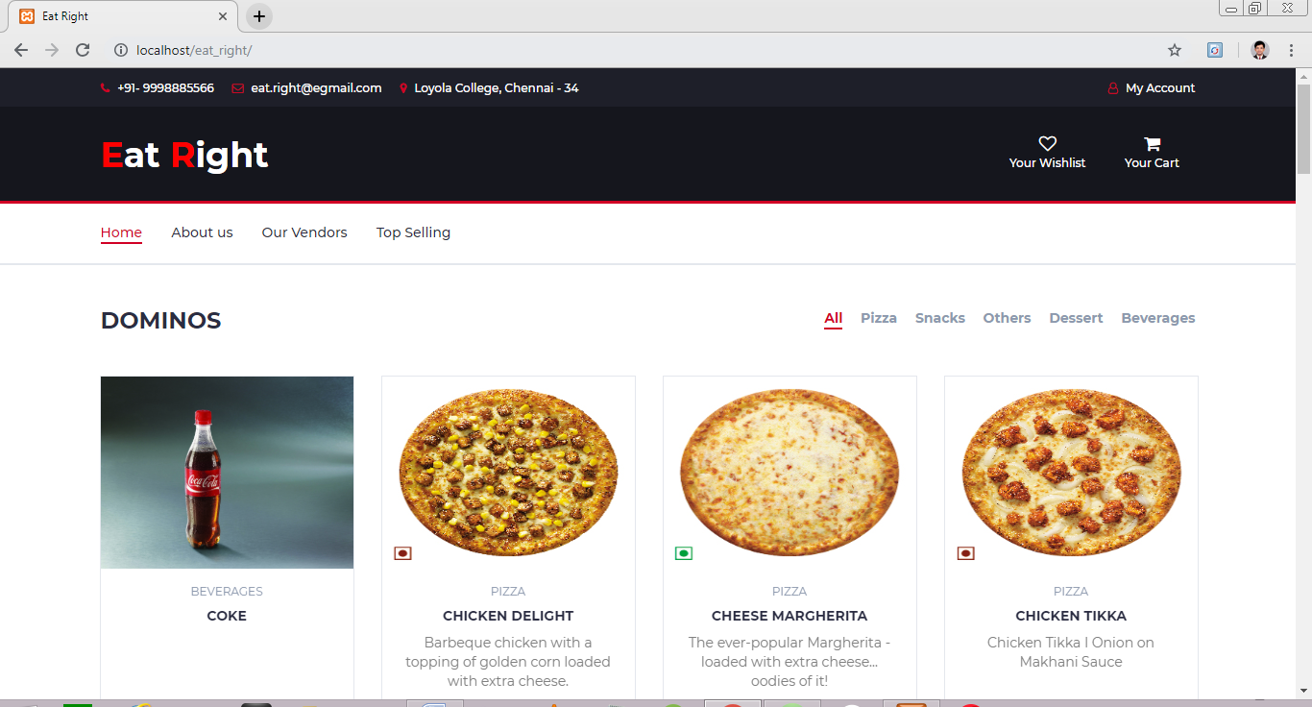

Figure No: 7.1 Customer’s Home Page

This is the home page of Eat Right. A user can view the details even without registering and login to their account. But, if they want to do any transactions they have to login first. For login, user has to click ‘My Account’ link.

**LOGIN PAGE : Customer**

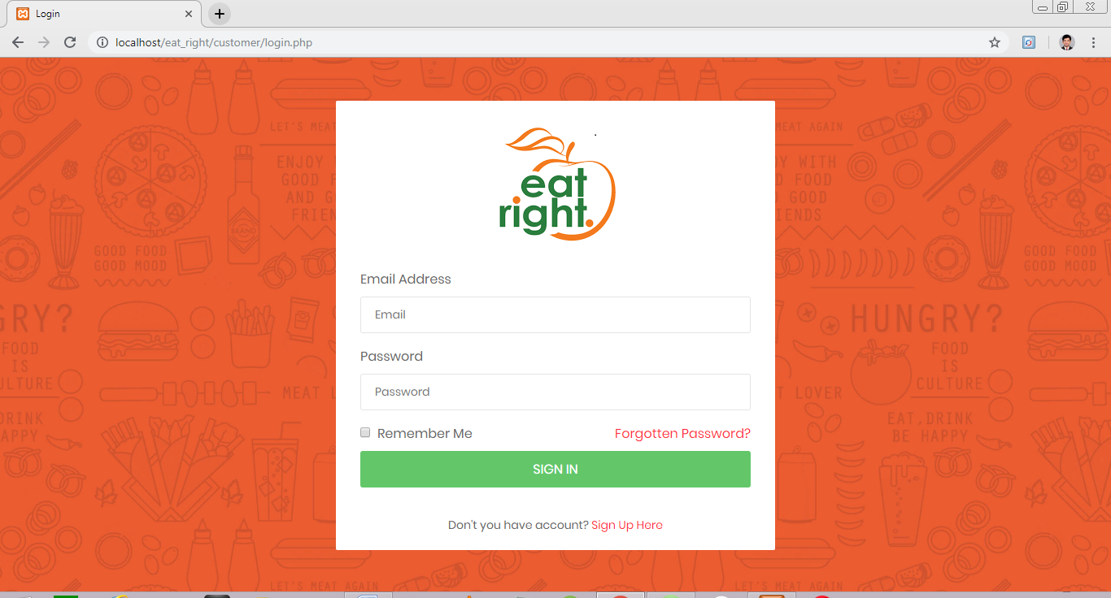

Figure No: 7.2 Customer’s Login Page

An already registered user can directly login to their account using this login page. Customer has to give their valid credentials and click the ‘SIGN IN’ button. If he doesn’t registered initially click on the ‘Sign UP Here’ link.

**REGISTRATION PAGE : Customer**

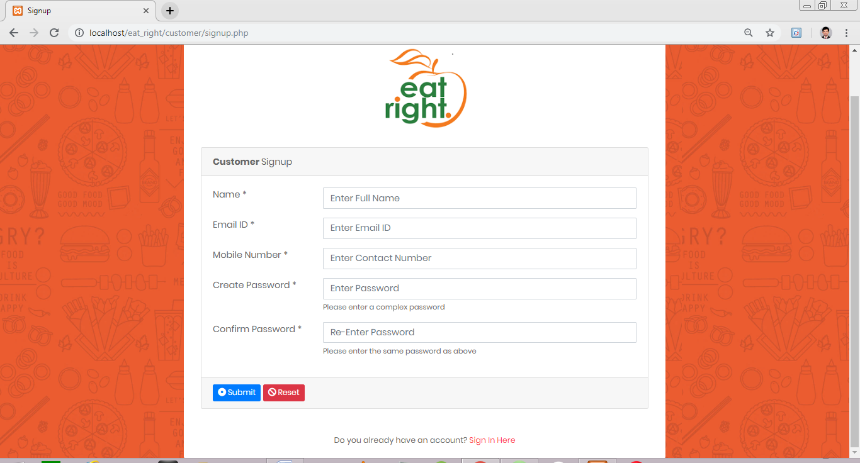

Figure No: 7.3 Customer’s Registration Page

New customers can register here with their basic details. If the person already have an account, then he can go to the sign in page by clicking ‘Sign In Here’ link.

**WISHLIST PAGE : Customer**

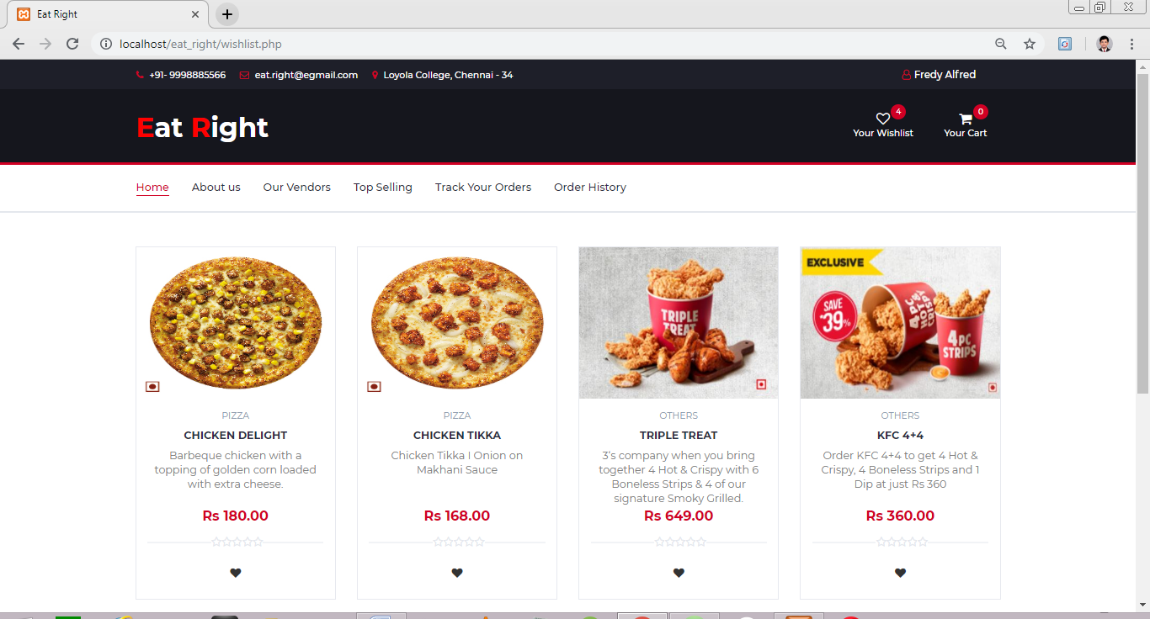

Figure No: 7.4 Wishlist Page

If the customer wants add an item to his wishlist, he has to click on the heart shaped button under that particular item. Click on the ‘Your Wishlist’ link to view the wishlist of the customer.

**CART PAGE : Customer**

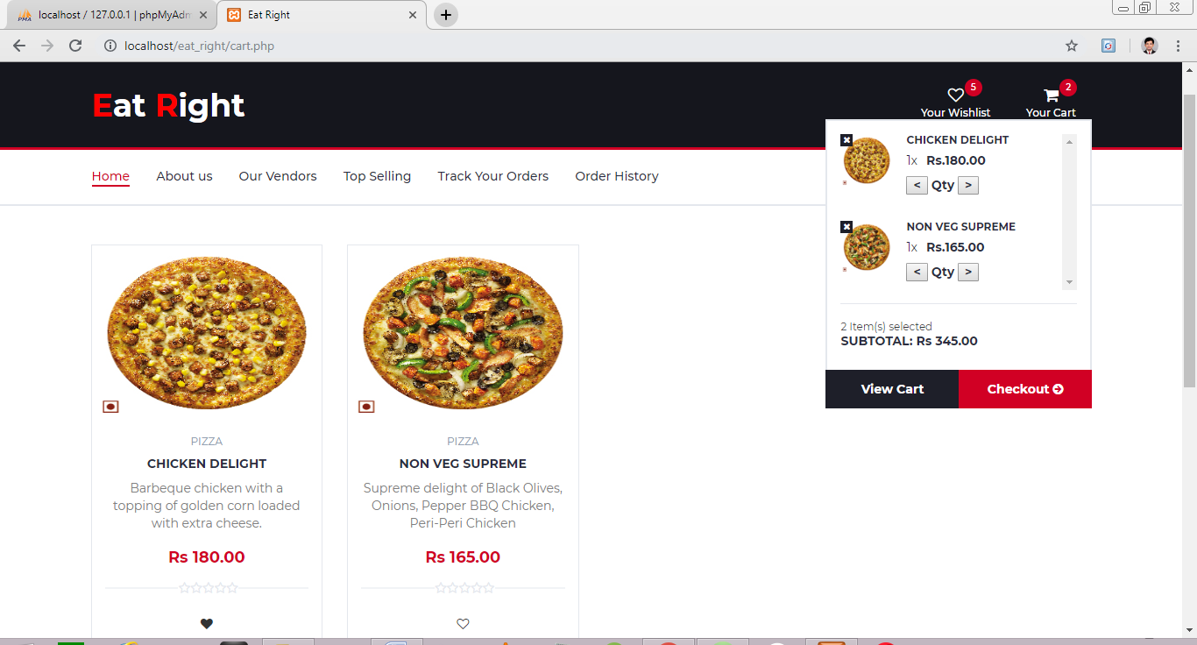

Figure No: 7.5 Cart Page

This is the cart page of the person who currently logined. Here we can find the items that are added to cart. We can also set the quantity of the items that we want. For checking out and placing order click on the ‘Chechkout’ button.

**CHECK OUT PAGE : Customer**

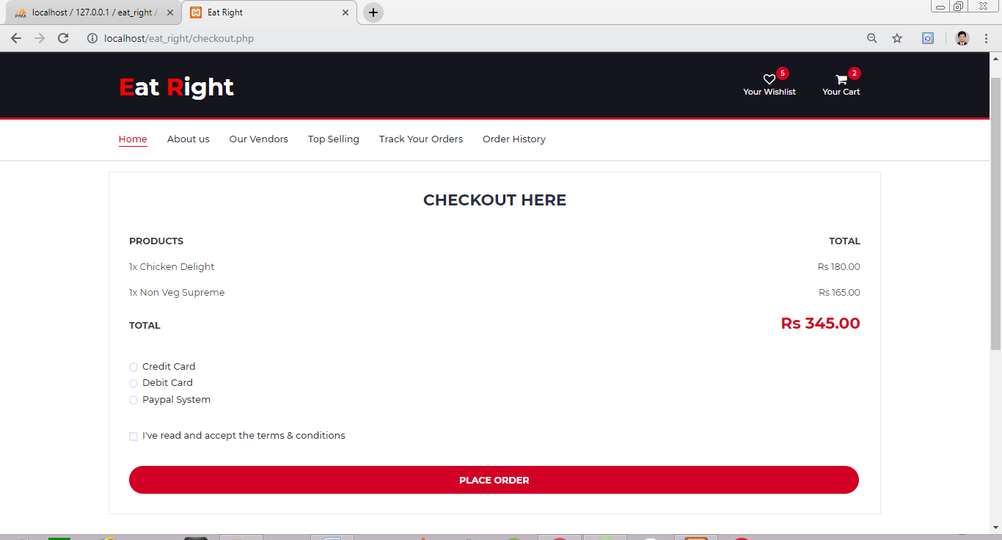

Figure No: 7.6 Check Out Page

This is the check out page. For placing the order click on the ‘PLACE ORDER’ button.

**VENDOR SPECIFIC STORE PAGE : Customer**

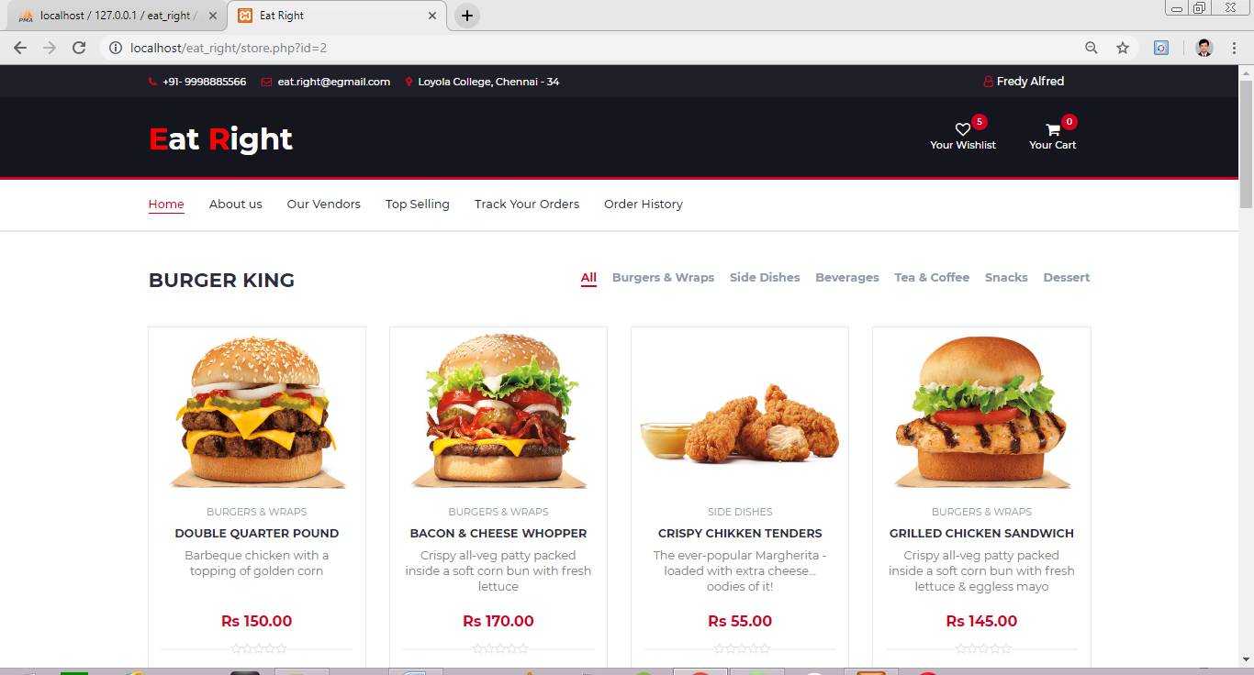

Figure No: 7.7 Vendor Specific Store Page

This is the vendor specific store page where we can find the food items in a particular store.

**TOP SELLING : Customer**

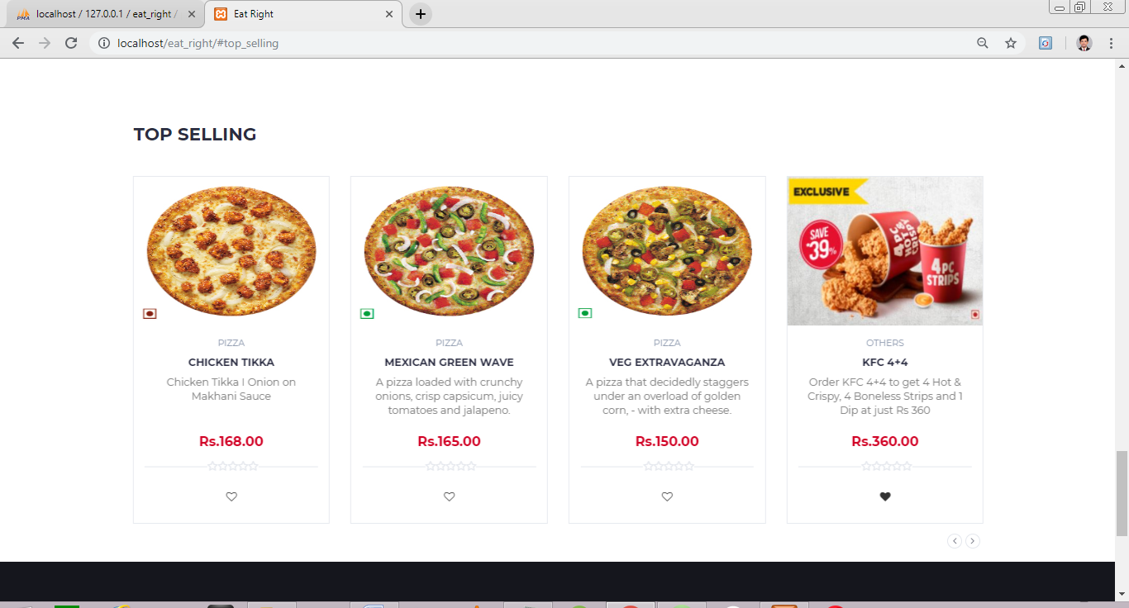

Figure No: 7.8 Top Selling

This is the top selling items section where the customers can find the top selling items over the whole vendors.

**LOGIN PAGE : Vendor**

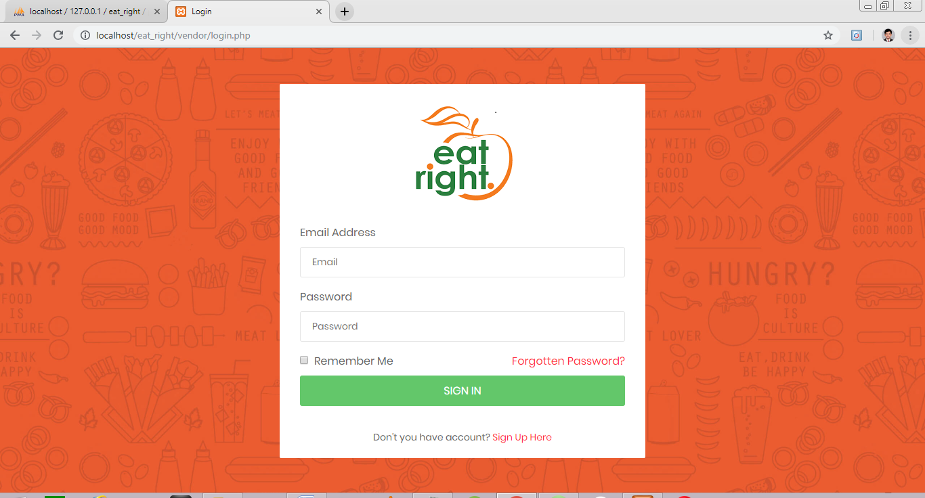

Figure No: 7.9 Vendor’s Login Page

An already registered vendor can directly login to their account using this login page. Customer has to give their valid credentials and click the ‘SIGN IN’ button. If he doesn’t registered initially click on the ‘Sign UP Here’ link.

**REGISTRATION PAGE : Vendor**

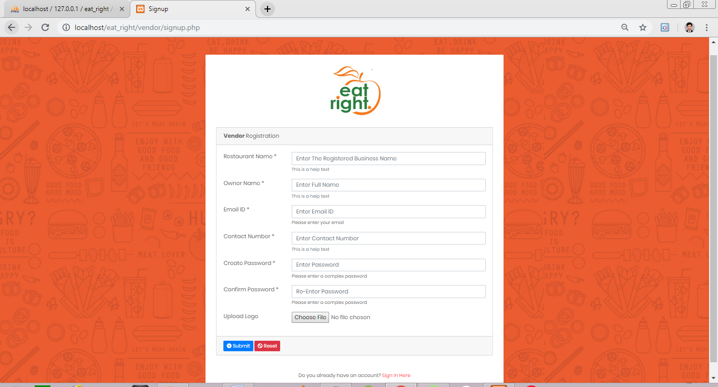

Figure No: 7.10 Vendors’s Registration Page

New vendors can register here with their basic details. If the vendor already have an account, then he can go to the sign in page by clicking ‘Sign In Here’ link.

**HOME PAGE : Vendor**

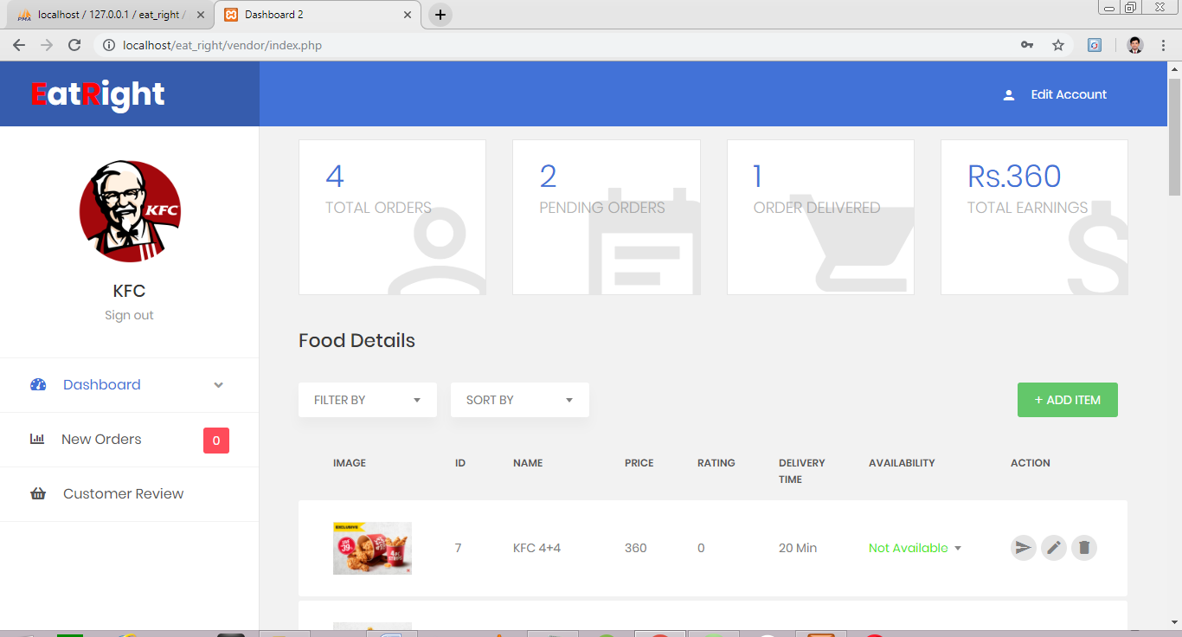

Figure No: 7.11 Vendor’s Home Page

This is the vendor home page. Here the particular vendor can manage the food items they have added. They can update the availability of the food item, edit the details of the item and also can delete a particular item from their menu.

Vendors can easily filter the food items based on the availability as well as they can sort the table by selecting any option. For sorting and filtering click on the ‘SORT BY’ and ‘FILTER BY’ dropdown controls respectively.

**ADD NEW ITEM PAGE : Vendor**

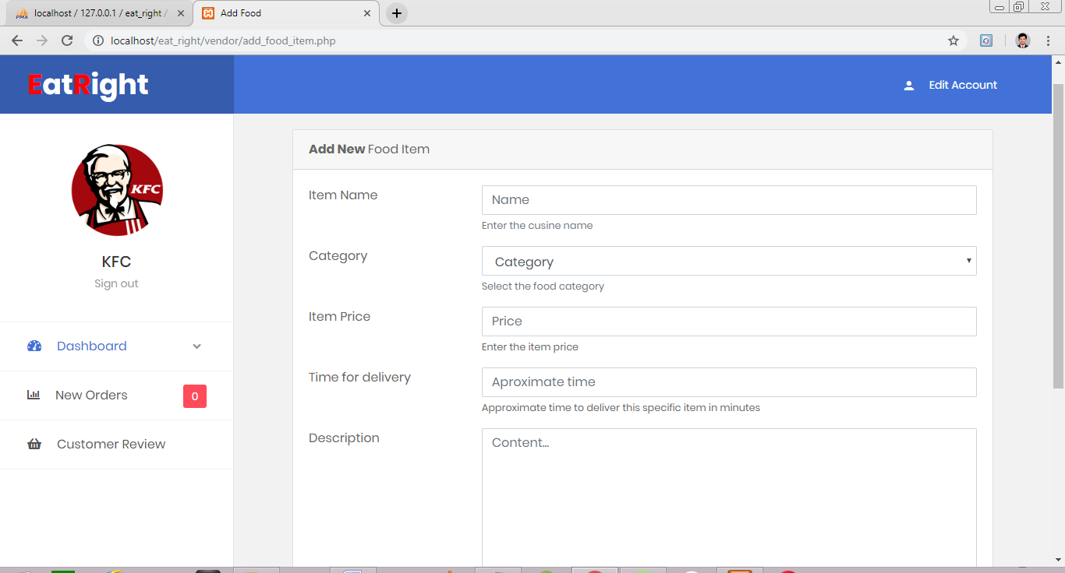

Figure No: 7.12 Add New Item

Here the vendors can add new food items. Fill the form and click on ‘Submit’ Button to add an item.

**VIEW ORDERS PAGE : Vendor**

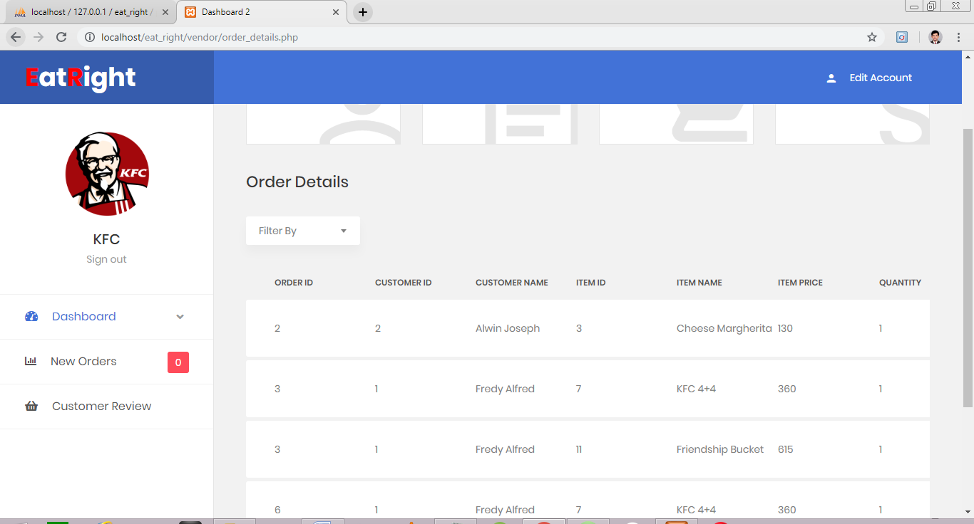

Figure No: 7.13 View Order Page

Here the vendors can see the whole order details they got. Vendors can filter the details for the easy management by clicking on the ‘Filter By’ dropdown button.

**NEW ORDER PAGE : Vendor**

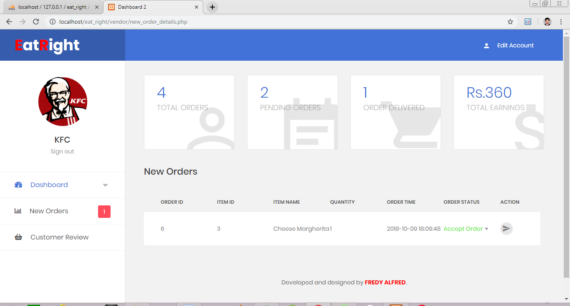

Figure No: 7.14 New Orders Page

Here the vendors can view the new orders and they can decide whether the order should accept or decline. Vendors can choose the option and click on the submit button in the action column.

**CUSTOMER REVIEW PAGE : Vendor**

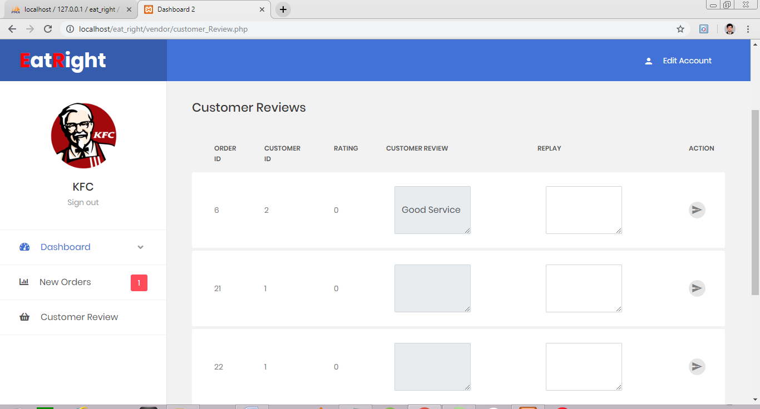

Figure No: 7.15 Customer Review Page

Here the vendors can see the customer reviews and also he can reply to it. Edit the reply in the text area and click on the submit button to send the reply.

**ADMIN HOME PAGE : Admin**

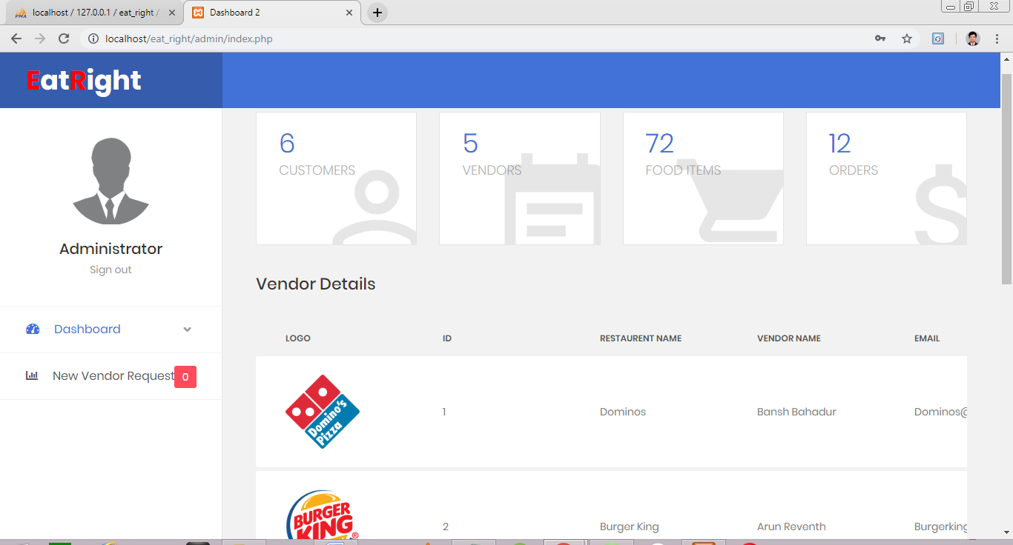

Figure No: 7.16 Admin’s Home Page

Here admin can find the different customers registered with Eat Right food court. Admin can change the status of the vendor even he can block a particular vendor.

**VIEW NEW VENDOR REGSTRATIONS : Admin**

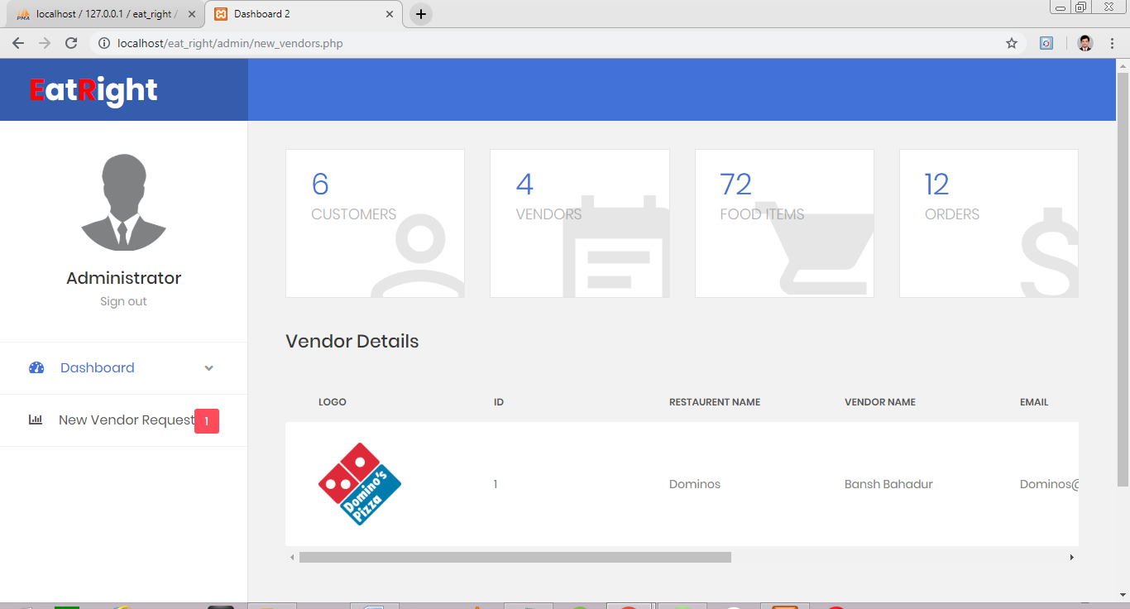

Figure No: 7.17 New Vendor Registration Page

Here the vendor will be notified for each new vendor registrations. Admin have the rights to accept / decline / or block the new vendor registrations.

**Chapter 8**

**SYSTEM DEPLOYMENT**

**Installation Procedure of XAMPP Server**

**Step 1**

**Open the XAMPP website.** Go to <https://www.apachefriends.org/index.html> in your computer's web browser.

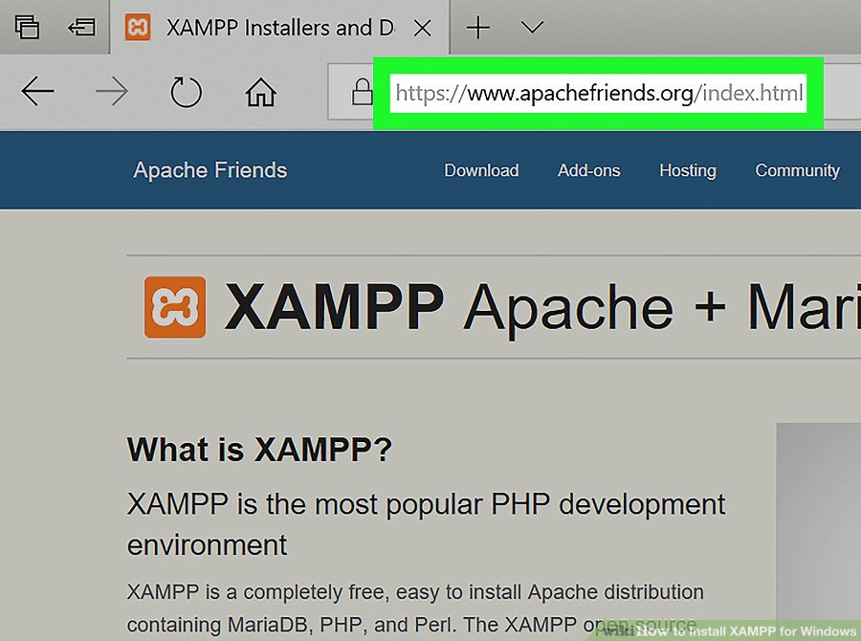

Figure No: 8.1 XAMPP Installation Screenshot

**Step 2**

**Click XAMPP for Windows.** It's a grey button near the bottom of the page.

* Depending on your browser, you may first have to select a save location or verify the download.

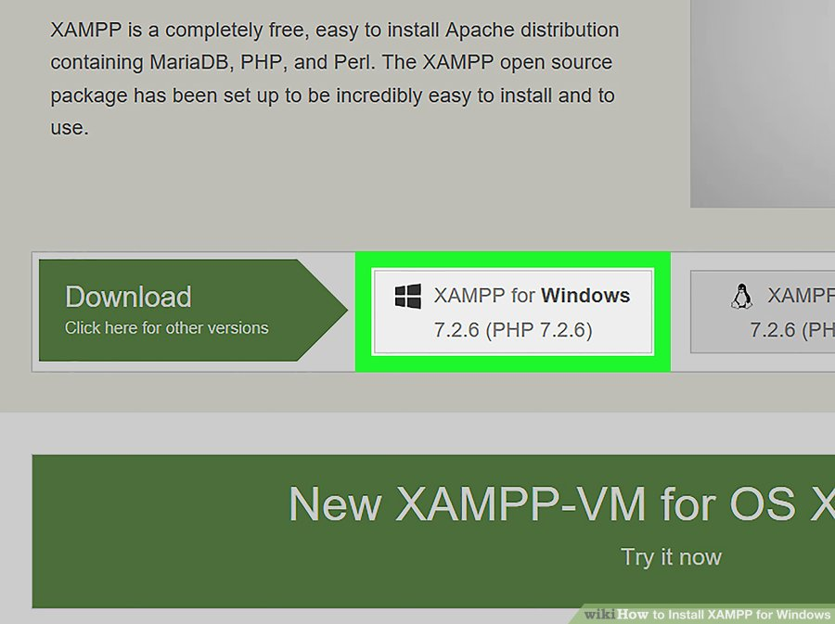

Figure No: 8.2 XAMPP Installation Screenshot

**Step 3**

**Double-click the downloaded file.** This file should be named something like **xampp-win32-7.2.4-0-VC15-installer**, and you'll find it in the default downloads location (e.g., the "Downloads" folder or the desktop).

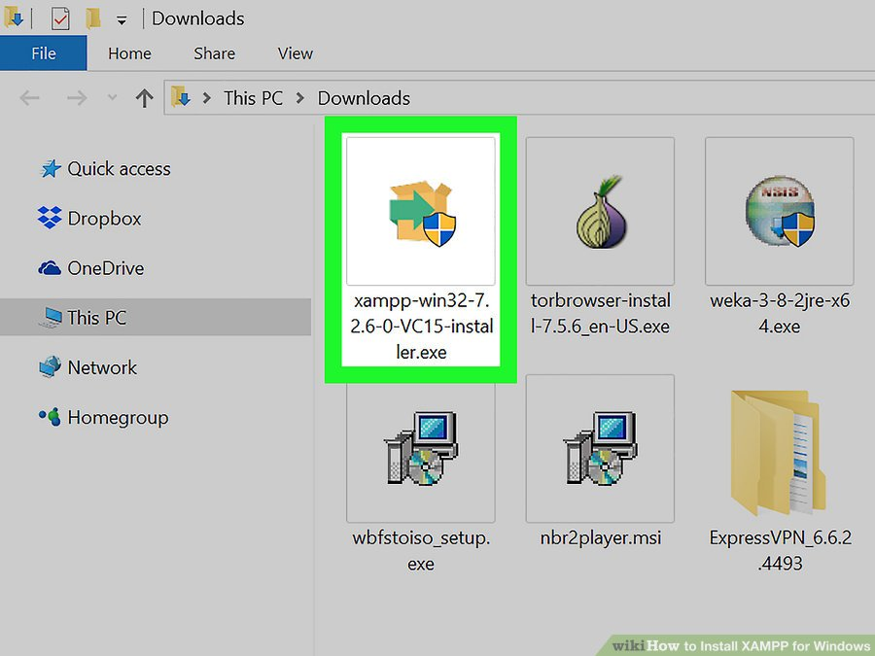

Figure No: 8.3 XAMPP Installation Screenshot

**Step 4**

**Click Yes when prompted.** This will open the XAMPP setup window.

* You may have to click **OK** on a warning if you have User Account Control (UAC) activated on your computer.

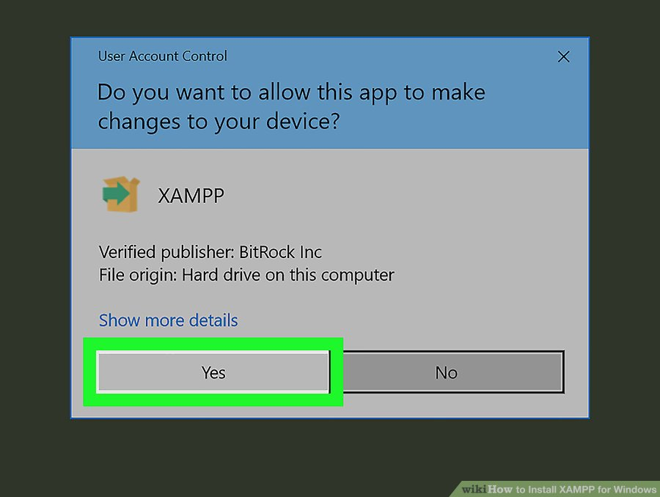

Figure No: 8.4 XAMPP Installation Screenshot

**Step 5**

**Click Next.** It's at the bottom of the setup window.

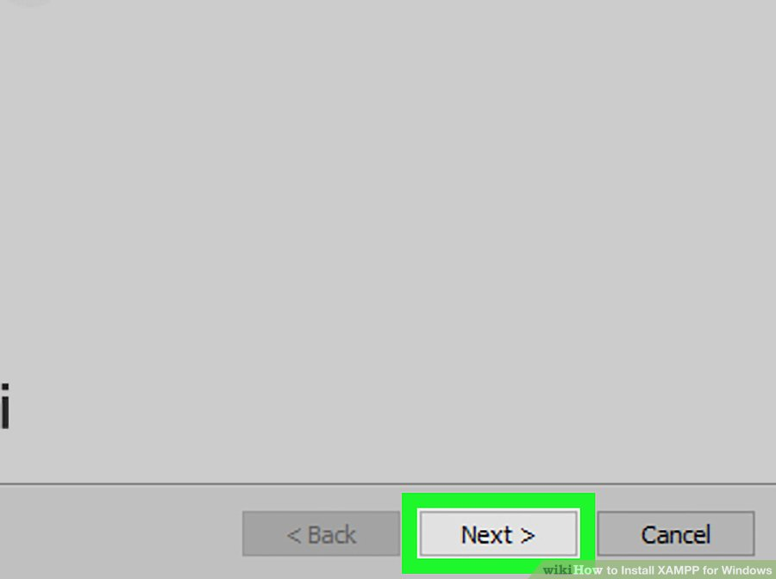

Figure No: 8.5 XAMPP Installation Screenshot

**Step 6**

**Select aspects of XAMPP to install.** Review the list of XAMPP attributes on the left side of the window; if you see an attribute that you don't want to install as part of XAMPP, uncheck its box.

* By default, all attributes are included in your XAMPP installation.

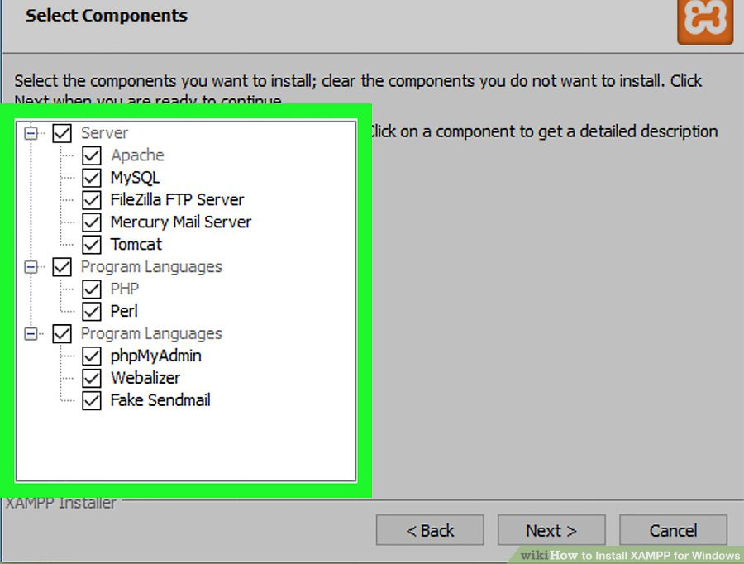

Figure No: 8.6 XAMPP Installation Screenshot

**Step 7   
Click Next.** It's at the bottom of the window.

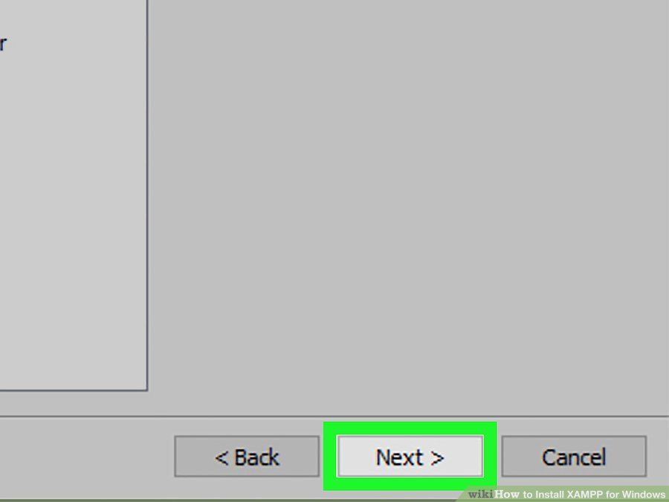

Figure No: 8.7 XAMPP Installation Screenshot

**Step 8**

**Select an installation location.** Click the folder-shaped icon to the right of the current installation destination, then click a folder on your computer.

* If you have the UAC activated on your computer, avoid installing XAMPP in your hard drive's folder (e.g., **OS (C:)**).
* You can select a folder (e.g., **Desktop**) and then click **Make New Folder** to create a new folder and select it as the installation destination.

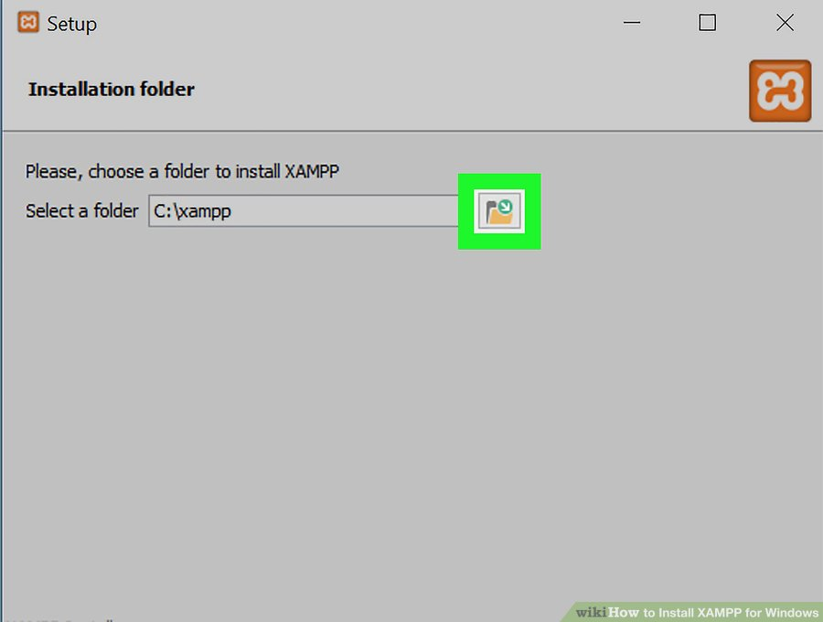

Figure No: 8.8 XAMPP Installation Screenshot

**Step 9**

**Click OK.** Doing so confirms your selected folder as your XAMPP installation location.

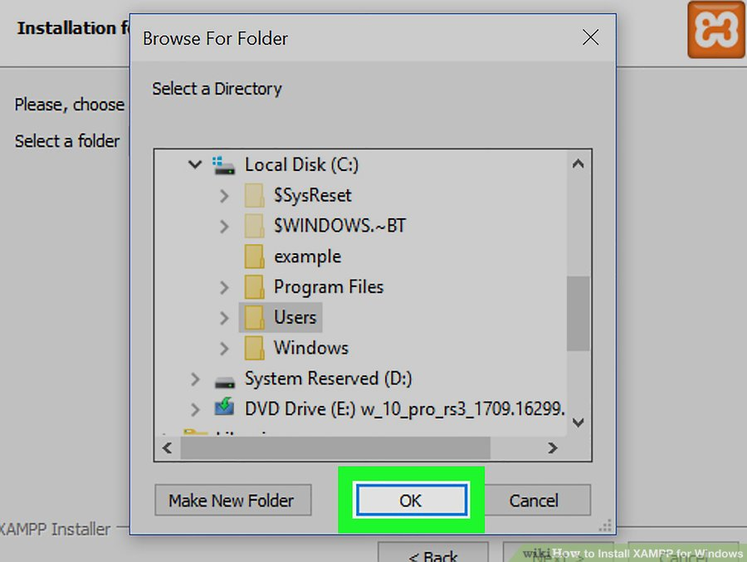

Figure No: 8.9 XAMPP Installation Screenshot

**Step 10**

**Click Next.** You'll find it at the bottom of the page.

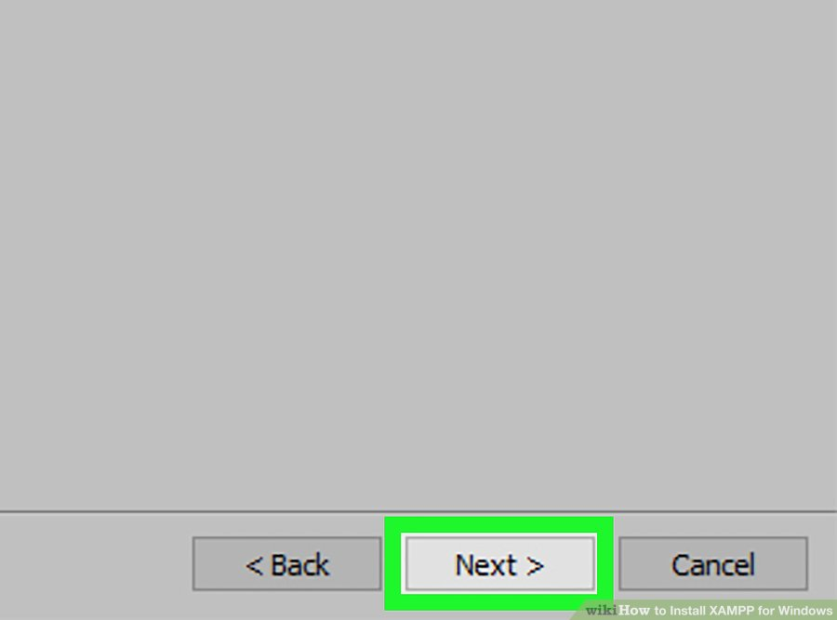

Figure No: 8.10 XAMPP Installation Screenshot

**Step 11   
Uncheck the "Learn more about Bitnami" box, then click Next.** The "Learn more about Bitnami" box is in the middle of the page.

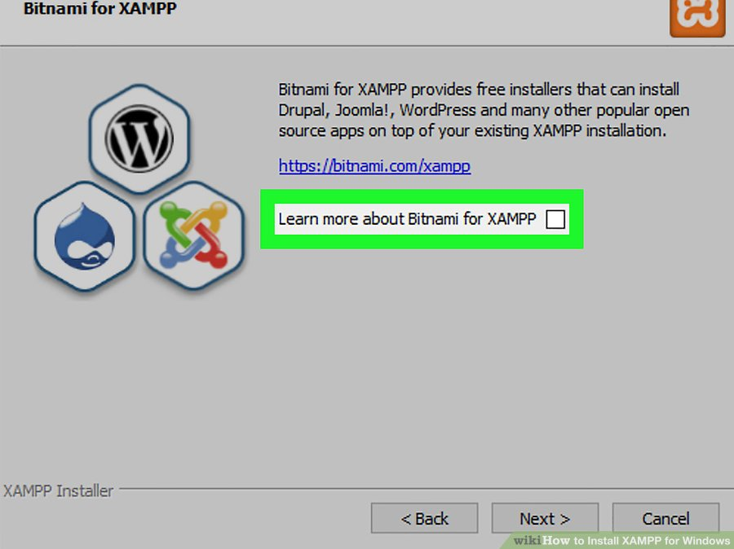

Figure No: 8.11 XAMPP Installation Screenshot

**Step 12**

**Begin installing XAMPP.** Click **Next** at the bottom of the window to do so. XAMPP will begin installing its files into the folder that you selected.

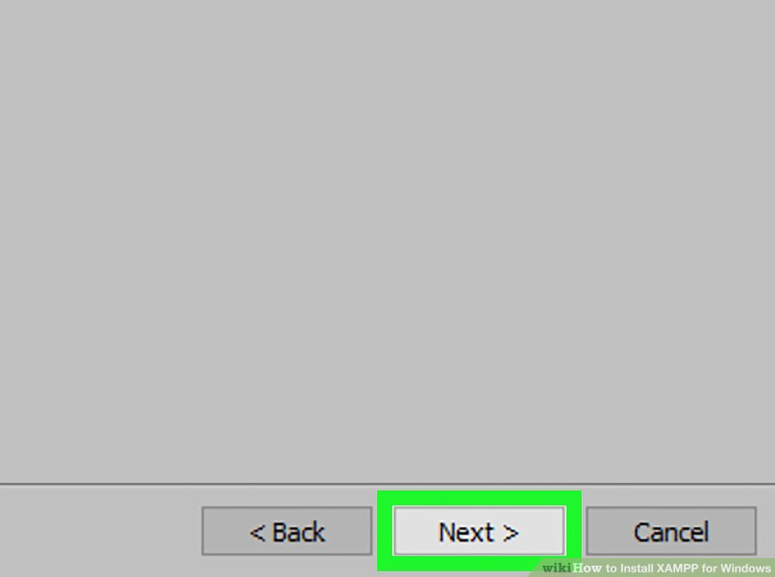

Figure No: 8.12 XAMPP Installation Screenshot

**Step 13**

**Click Finish when prompted.** It's at the bottom of the XAMPP window. Doing so will close the window and open the XAMPP Control Panel, which is where you'll access your servers.

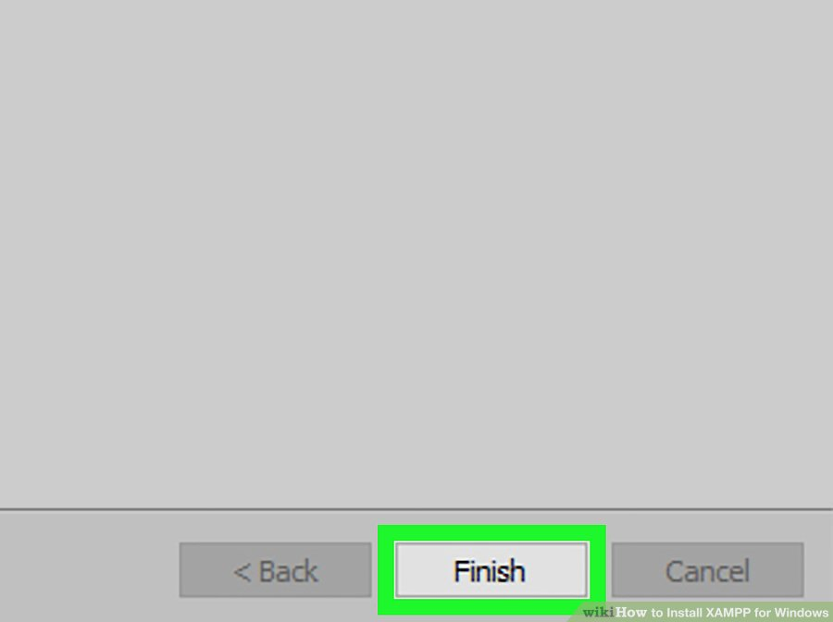

Figure No: 8.13 XAMPP Installation Screenshot

**Step 14**

**Select a language.** Check the box next to the American flag for English, or check the box next to the German flag for German.

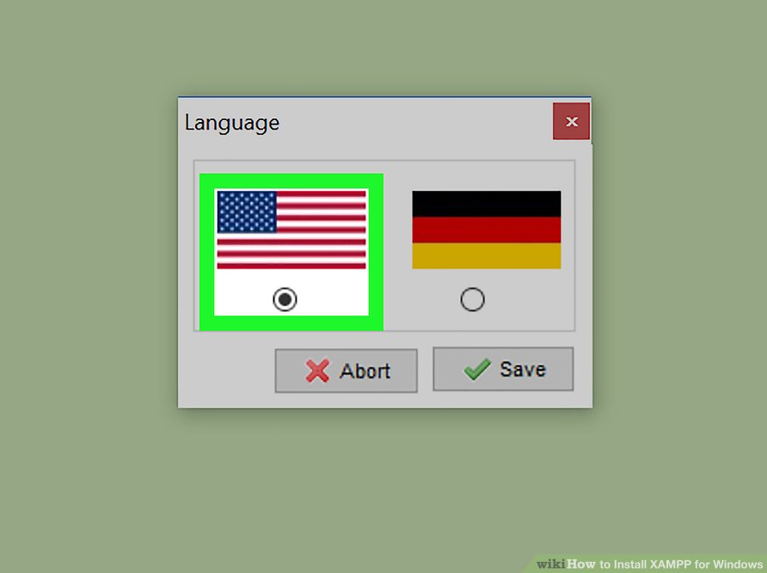

Figure No: 8.14 XAMPP Installation Screenshot

**Step 15  
Click Save.** Doing so opens the main Control Panel page.

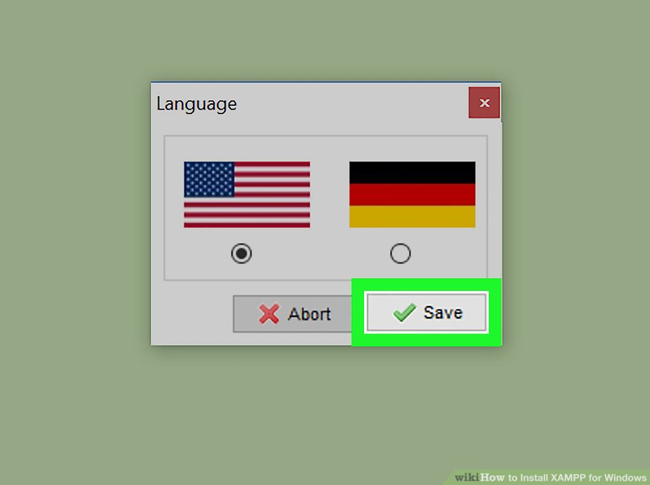

Figure No: 8.15 XAMPP Installation Screenshot

**Step 16  
Start XAMPP from its installation point.** If you need to open the XAMPP Control Panel in the future, you can do so by opening the folder in which you installed XAMPP, right-clicking the orange-and-white **xampp-control** icon, clicking **Run as administrator**, and clicking **Yes** when prompted.

* When you do this, you'll see red **X** marks to the left of each server type (e.g., "Apache"). Clicking one of these will prompt you to click **Yes** if you want to install the server type's software on your computer.
* Counterintuitively, double-clicking the **xampp_start** icon doesn't start XAMPP.

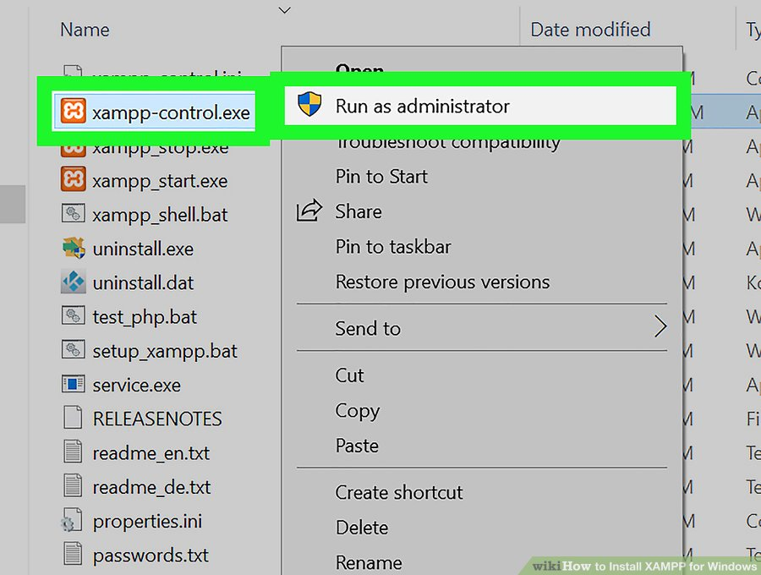

Figure No: 8.16 XAMPP Installation Screenshot

**Step 17**

**Resolve issues with Apache refusing to run.** On some Windows 10 computers, Apache won't run due to a "blocked port". This can happen for a couple of reasons, but there's a relatively easy fix:

* Click **Config** to the right of the "Apache" heading.
* Click **Apache (httpd.conf)** in the menu.
* Scroll down to the "Listen 80" section (you can press Ctrl + F and type in listen 80 to find it faster).
* Replace 80 with any open port (e.g., 81 or 9080).
* Press Ctrl+S to save the changes, then exit the text editor.
* Restart XAMPP by clicking **Quit** and then re-opening it in administrator mode from its folder.

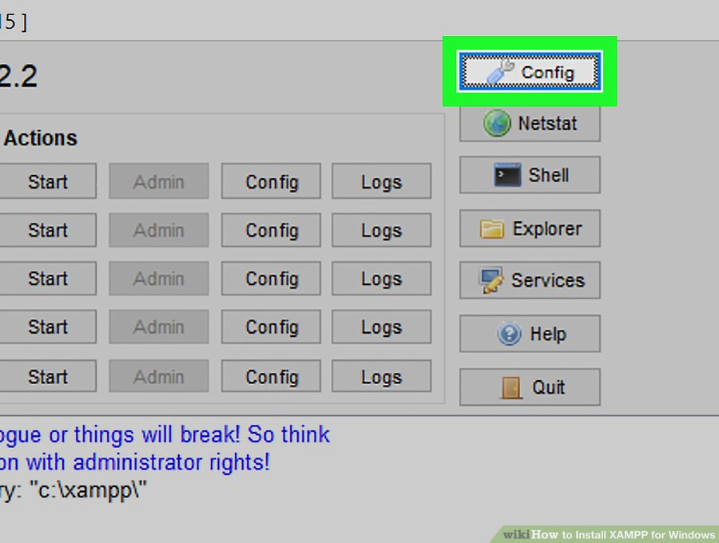

Figure No: 8.17 XAMPP Installation Screenshot

**Chapter 9**

**CONCLUSION**

The Eat Right – Web application for the automation of a food court management is working properly as per the expectation and satisfies all the conditions. Currently the system can handle customers/users but in future more storage space is needed to audit the entire log files. In user management this system developed with same authentication mechanism where customer, vendor and admin can login with different pages. This leads to reduce complexity and maintaining resources effectively. This is developed based on the basic knowledge of selling foods, as per certain policy of the food courts. The interaction between customers and vendors is well executed and deployed. This system automates all the food court management processes in the existing system. Customers can see the different food items, vendors, and top selling items in the customer module. They can also register and login for ordering food and also they can make a wish list as well. They can pre-order the food even before enter into the food court so that they don’t need to wait for the food to be delivered. Once the food is ready they will get a notification regarding that. Vendors can also register with the vendor module. They can add new food items, edit existing food’s details, view the orders etc through their own page. They can also change the status of existing food items whether it is available or not so that only the available items will be shown in the customer module.

This application reduces the tensions in the existing system to a large extent. By registering in this web application, both by the restaurants and customers, one can order food through online in advance so that they won't have to wait for a long time. So it saves a lot of time and reduces the crowd in front of the food stalls rather effectively.

**Chapter 10**

**FUTURE ENHANCEMENTS**

As the future enhancements, we can introduce the following features

* Integrate inbuilt Wallet options for easy payments
* Integrate different payment gateways after deploying the application as live project
* Integrate AI based Chatbot for managing the application with speech commands
* Report generation for vendors
* Related products section for each product
* Mobile phone message alert to the customers for notifying their order is ready to be served
* Uploading images in customer review section
* Convert the customer module into a hybrid mobile application with cross platform usability which makes easy to use the application

**Chapter 11**

**BIBILOGRAPHY**

**BOOK REFERENCES**

1. Laura Thomon, “PHP and MySQL Web Developmnt”, Pearson Edition, 2nd Edition, 2008.
2. Dave Mercer, “PHP Beginners’ Guide”, Tata McGraw- Hill Publications, 2001.

**WEB REFERENCES**

* <https://www.w3schools.com/php/php_variables.asp>
* <https://www.w3schools.com/php/php__switch.asp>
* <https://www.w3schools.com/php/php_arrays_sort.asp>
* <https://www.w3schools.com/php/php_forms.asp>
* <https://www.w3schools.com/php/showphp.asp?filename=demo_form_validation_escapechar>
* <https://www.w3schools.com/php/php_form_url_email.asp>
* <https://www.w3schools.com/php/php_form_compete.asp>
* <https://www.w3schools.com/php/php_exception.asp>
* <https://www.w3schools.com/php/php_mysql_insert_multiple.asp>
* <https://www.w3schools.com/php/php_mysql_connect.asp>
* <https://w3layouts.com/builders-and-real-estates/>
* <https://coolestguidesontheplanet.com/how-to-connect-to-a-mysql-database-with-php>
* <https://www.tutorialspoint.com/php/php_mysql_login.html>

**APPENDIX A : Data Dictionary**

|  |  |
| --- | --- |
| **VARIABLE NAME** | **MEANING** |
| Uname | User name |
| User_Id | User Identification |
| Vname | Vendor Name |
| V_id | Vendor Identification |
| Admin_Id | Administrator Identification |
| Pwd | Password |
| Email | E-Mail ID |
| ph.no. | Phone Number |
| mob.no. | Mobile Number |
| Dob | Date Of Birth |
| del_time | Delivery Time |
| Sex | Gender |

**APPENDIX B : Screen Shots**











